Glue Ear
Advice for Early Years Children

Many young children have reduced hearing due to Glue Ear. Glue ear is especially prevalent in young children, especially at around 2 and 5 years old, as they start nursery or school. It is often associated with congestion from coughs and colds.
Glue ear tends to be worse during the winter months.

What is Glue Ear?

Glue ear occurs when the middle ear is filled with a sticky fluid, similar to the mucous produced by the nose during a cold. When this fluidy mucous becomes thick it can affect hearing because it prevents sound from being effectively transferred through the middle ear – it prevents the little bones from moving and passing on the sound vibrations from the ear drum.

We call it glue ear because the fluid is sticky. Other names for this condition can be a fluctuating conductive hearing loss, or Otis Media with effusion.

Why does it happen?
The Eustachian tube is responsible for draining the middle ear. We feel our eustachian tube opening and working when we swallow and feel our ears pop or clear, as it allows air to enter the middle ear. In adults the slant of the eustachian tube is quite steep.

In very young children, the eustachian tube is narrow and tends to lie horizontally, so it doesn’t allow the middle ear fluid to drain effectively. When the eustachian tube is blocked, fresh air can’t enter the middle ear and the lining of the middle ear produces this sticky fluid.
The eustachian tube develops a slant as children grow, and once a toddler is up and moving it tends to drain more easily.
Children tend to grow out of glue ear by around 8 years old, although sometimes it persists for longer.

Signs and symptoms and how to identify Glue Ear
Glue ear can go unnoticed in a young child. If often occurs at the age and stage when a young child is learning to communicate; still has a short attention span; and likes to do things their way.
Hearing and listening becomes hard work and tiring, so young children tend to ‘zone out’ more. It’s easy to think that their listening is ‘selective’.
Glue ear can:
- Cause physical discomfort: Children might:
- rub their ears and complain their ears feels sore or full or are popping.
- be more prone to ear infections.
- have frequent colds and a persistent snotty nose.

- Affect hearing and listening. Children with glue ear may:
- Find it difficult to hear speech, work out who is talking and follow a conversation.
- Not respond to their name when called.
- Find it difficult to concentrate and attend to what’s happening, particularly in noisy situations.
- Mishear instructions, and asking “Eh?” And “What?” a lot.
- Want to turn the TV up louder.
- Find listening becomes really hard work, so quite often children with long-term glue ear have never developed good listening habits, are easily distracted and find sustaining focus for group activities a challenge.

- Affect speech and language development
- There may be a delay in the child acquiring language; slow to talk, and even babble.
- A child’s speech may sound woolly and unclear; they may lose or substitute speech sounds – the impact usually depends on their age and stage. The younger the child, the greater the likelihood of delay in language acquisition.
- When children aren’t hearing clearly they either tend to talk less and lose confidence or talk more (and talk quite loudly!) because speaking is so much easier than listening. Sometimes they can be perceived as quite loud and demanding.
- When Glue Ear persists as children move into school, it can impact vocabulary development and acquiring phonics.

- Affect social and emotional development
Always remember – behaviour is communication
- At a young age, the frustration of not understanding or being misunderstood can impact behaviour.
- Children may become frustrated or withdrawn and prefer to play alone because they are not able to hear others sufficiently clearly.
- It’s much easier to understand and play with adults who have louder, clearer speech than it is with other young children. Your child may seem to prefer playing with adults.
- A child with glue ear may appear to misbehave, simply because they have not heard and respond inappropriately. Some children will ‘switch off’ and appear to be in a world of their own as they are unable to access speech reliably.
- Listening in a group situation is always challenging, so your child might have difficulty concentrating and appear dreamy (rolling on their back with their feet in the air; fiddling with their socks and the Velcro on their shoes) if you attend a local group.

How to manage fluctuating but persistent Glue Ear:
If parents suspect their child may have a hearing loss they need to visit the GP for a hearing check and a referral to ENT and Audiology. As glue ear can fluctuate, it can sometimes be hard to ‘catch’. Parents often report knowing their child hasn’t been hearing well for ages before it has been diagnosed. The child’s hearing and the impact of glue ear is monitored by ENT. Not all children with glue ear will be fitted with hearing aids or grommets.

Hearing aids
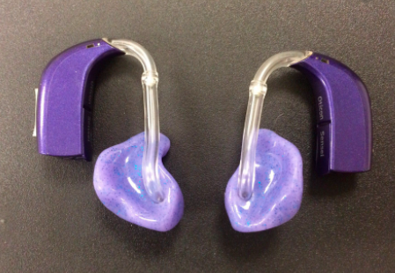
When Glue Ear is found to be persistent and is impacting a child’s language development, the child is likely to be offered hearing aids.
Hearing aids can be fitted on young children and babies – different colours, types and sizes.
Behind the ear hearing aids require ear moulds to be made regularly.
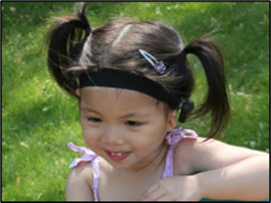

A BAHA (Bone Anchored Hearing Aid) is usually worn on a soft band and is especially useful if the child suffers with recurrent ear infections.
When a child is fitted with hearing aids at Audiology, parents are then offered a referral to our team for further support.

What about grommets?

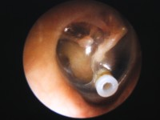
Grommets are tiny plastic tubes a bit like a rivet.
They are inserted into the eardrum under general anaesthetic and are designed to reduce the pressure and vent the middle ear, enabling the glue ear to drain and clear.
Parents are always offered the option of temporary hearing aids as an alternative to grommets to delay the need for an operation.
Grommets gradually work their way out of the ear usually between 9 and 15 months and the ear drum heals. However, sometimes they only last a few weeks, so don’t assume they are necessarily a ‘magic wand’! In fact, about a third of children will need another set within 5 years.

An Otovent
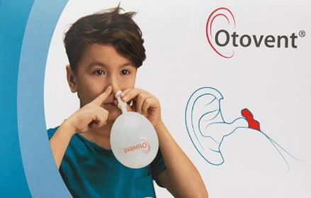
An Otovent balloon can be used by children over the age of 3 years, if they can blow through their nostrils. Blowing through one nostril to inflate the balloon (while blocking the other) can help clear the eustachian tube.

How can we support a child with glue ear?

- Get the child’s attention before you start speaking.
- Make sure the child can see your face, make eye contact and smile.
- Where possible, reduce background noise, making it easier for the child to listen.
- Speak clearly, with normal intonation and rhythm - don’t shout.
- Use short sentences and support what you are saying with pictures or objects.
- Repeat back what other people have said, so the child can understand and respond appropriately.
- Encourage the child to vocalise; repeat what the child has said and expand on it, modelling the language they might use in time.

Find ways to engage and motivate your child. Achieving joint attention (where you are both focused on the same thing) is the key to meaningful communication.


Singing and rhythmic music-making is great at engaging small children - we tend to smile when we sing, which is always encouraging!
It’s often easier to hear a singing voice with lots of rhythm and intonation than normal speech. Words are often repeated, making them easier to copy and encourages vocalisations.

- Do make some time to sing with your child every day!
- Stay close and face each other; reducing background noises if you can.
- Choose songs with repeated phrases, so your child can learn them and join in easily.
- Use lots of actions and gestures to support the words you’re singing.
- Find a good tune and use it to sing through the activities throughout your day (Coming round the mountain often works well!)

Background noise is always unhelpful for hearing and listening well.
It is typically busy and noisy at Nursery or Pre-school, so it is important to consider how to make the environment a quieter place to make listening easier for all the children.

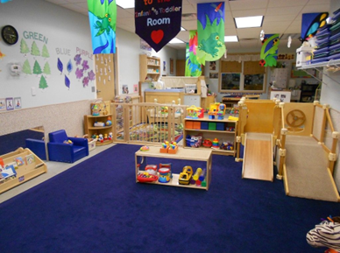
Soft surfaces can help absorb sound and diminish background noise:
- Big rugs on hard floors with cushions and bean-bags
- Curtains and blinds at windows
- Wall displays with textures and fabric drapes (not lots of laminated sheets)
- Foam or sponge inside pencil/pen pots and carpet in the bottom of toy trays to prevent objects clattering.

Reduce background noise whenever you can:
- Please do close windows and doors if it’s noisy outside.
- Turn off unnecessary heaters, fans, projectors whenever possible.
- Lots of Nurseries and Pre-schools like to have music playing in the background. Please consider the volume and whether this is really adding to your environment.

Hearing to Succeed and Achieve – Ewing Foundation

