General advice for children with hearing loss
in Early Years settings

“In this document the terms ‘deaf’ and ‘deafness’ are used to refer to all types and levels of hearing loss.”

It is important to remember that children with any kind of deafness have to work much harder to understand the language around them. They are concentrating hard all day and searching for additional cues to make sense of what people are saying and asking of them. They are therefore often very tired by the end of a day with good reason.
Here are some strategies which help to ease the burden of concentration for children with hearing loss in their setting and help them access and develop good language:
- Check that personal hearing aids or cochlear implants and other pieces of equipment are working well at the beginning of each session. The Teacher of deaf children and young people can give training on this.
- Make sure that they can see your face when talking to them – especially if it is in background noise. They will gain additional information and reassurance from seeing facial expression and lip patterns.
- If you are having a group time seat them away from any background noise. If they have a better hearing ear, make sure this is towards the person speaking. Let them see the other children in the group as they will watch them for additional cues.
- Get the child’s attention first before you speak so they don’t miss the beginning of your sentence.
- Keep your face still when you speak and use normal pace. Use a lively interesting voice to engage their interest. Give lots of good rich language.
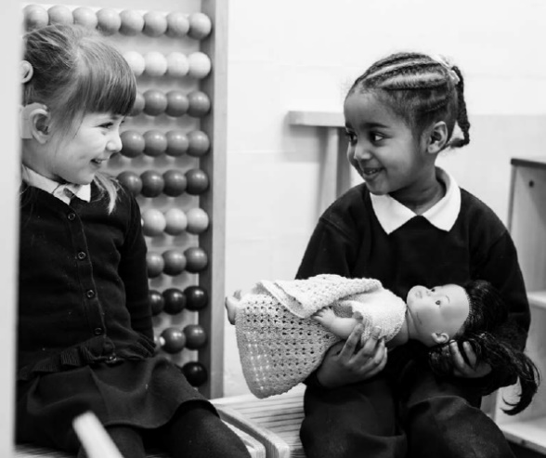
- Use as many visual aids as possible – pictures, objects, puppets etc. Point to the things you are talking about as you go along. This will help hugely with vocabulary development.
- Avoid sitting with your back to a light window. This causes your face to become a silhouette and prevents facial expression and lip pattern from being clear.
- Manage additional equipment well e.g. switch assistive listening devices ON when the child needs to be listening to you and MUTE when they don’t.
- Repeat the things that other children say as these are often quieter and can be missed. These contributions are so valuable and it is a shame for other children to miss them.
- Keep background noise to a minimum especially when concentrated listening is required.
- Children with a hearing loss may need extra thinking time to process a question and formulate an answer. Allow for this.
- It can be helpful to send home stories shared at nursery for the child with a hearing loss to go over the new vocabulary and gain additional understanding at home with their family.
- You may consider making a home-school book with photos or pictures to give children whose language is still developing a way to share what they have been doing at nursery with their families.
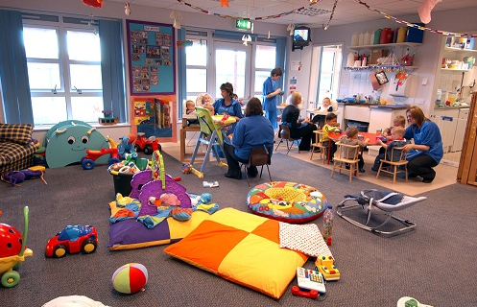
- Consider the acoustics of your learning environment. Anything you can do to improve it will help. Generally, this means introducing soft materials which help to absorb sound and so reduce reverberation e.g. use carpet, rugs, mats, beanbags, cushions, soft drapes in displays, padding the bottom of trays or pen/pencil pots etc., thick felt on table tops to reduce bangs and crashes from puzzles/bricks, a cushioned protective table covering for snack time, hush-ups on the bottom of chair legs, specialist acoustic treatment etc. Your Teacher of deaf children and young people can look at the environment with you and offer suggestions.

More information can be found in the National Deaf Children’s Society publication:
Supporting the achievement of children who are deaf in early years settings
Deaf-friendly early education.pdf

