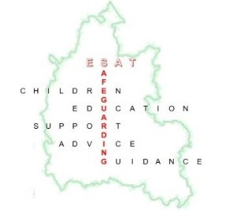
Education Safeguarding Advisory Team (ESAT)
Safeguarding Conference

Friday 5th June 2026
Unipart House, Garsington Road, Cowley, Oxford. SAT NAV postcode - OX4 6LN.

Agenda:

Arrival from 9am – Refreshments and pastries

9.30am start - Welcome

Beyond Behaviour: Embedding Cultural Awareness and Sensitivity in Education
Hidden in Plain Sight: Disparities, Adultification, and Intergenerational Trauma
The Liminality Group

11-11.20am - Break

The Liminality Group continued.

12.30-1.15pm - Lunch

1.15-2.15pm - Why a Multi-Agency Approach is Essential for Keeping Children Safe in Sport

Synopsis - Why a joined-up, multi-agency approach is essential for keeping children safe in sport. It highlights that sports clubs and activity providers often play a significant role in children’s lives, particularly for those who may be disengaged from school or have limited trusted adults outside the family home. The key message is that safeguarding children in sport cannot sit with clubs alone. Schools, safeguarding partnerships, local authorities, National Governing Bodies, welfare officers and community organisations all have a role in building safer environments and ensuring concerns are identified, shared and acted effectively.

Graham Smith, Senior Consultant, NSPCC Sport
Heidi Yates, Active Oxfordshire

2.15-2.25pm - Break

2.25-3.10pm - Learning from the Child and Adolescent Harmful Behaviour Service (CAHBS)
Mat Lister and Faye O’Connor

Copies of all today’s presentations will be available to download via the Education Services booking platform.

Please direct any queries or questions to the ESAT team at ESAT.safeguardingchildren@Oxfordshire.gov.uk

