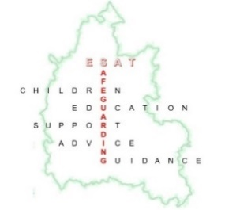
Education Safeguarding Advisory Team (ESAT)
Safeguarding Conference

Friday 6th February 2026
Unipart House, Garsington Road, Cowley, Oxford. SAT NAT postcode - OX4 6LN.

Agenda:

- 9am arrival – Refreshments and pastries

- 9.30am start - Welcome

- 9.30- 9.40am - ESAT feedback from the Section 175/157

- 9.40- 10.40am - The Police & Crime Commissioner’s Education strategy - Matthew Barber and DI Iain Roberts, Harm Reduction Unit

- 10.40-11am - Families First - Delia Mann/James Carter

11-11.20am BREAK

- 11.20- 12.05 - An update from Prevent - Cheri Fayers - DfE Prevent Regional Lead for Education
- National home office stats of interest
- Reminder of duty and CTLP/Risk assessment
- National and local threats from CTLP and other trends.
- Any updates on Southport inquiry/Prevent thresholds etc.

- 12.05- 12.45 - Introducing SAFER and Youth Justice- Jessie Dobson/Alison Brookman

12.45-1.25pm- LUNCH

- 1.25- 2.15pm - Safer Recruitment - 'Embedding robust safer recruitment practices in the education sector' - Carolyn Eyre, Safer Recruitment Consortium

2.15-2.25pm BREAK

- 2.25- 3.10pm - Child Protection conference and Multi-agency Chronology, Sharon Laird and Ruth Bryant

- 3.15pm Closing and goodbye

Copies of all today’s presentations will be available to download via the Education Services booking platform.

Please direct any queries or questions to the ESAT team at ESAT.safeguardingchildren@Oxfordshire.gov.uk

Break out stands including Fostering, NSPCC

