**Oxfordshire**

**Literacy Assessment Pack (LAPack)**

**Assessment of Early Literacy Skills**

**Oxfordshire School Inclusion Team (OXSIT)**

OCC NEW LOGO 2013 RGB**The Literacy Assessment Pack**

**Introduction**

The Literacy Assessment Pack (LAPack) was based on the original guidance given in the Oxfordshire Dyslexia Policy and Guidance (January 2002). It provides a generic assessment of basic reading skills, which can be used to unpick pupils’ difficulties, identify next steps in learning and track progress. It has been updated in line with the revised ‘Literacy Difficulties Policy and Advice’ (2015).

The Pack consists of the instructions and materials to enable you to assess the basic literacy skills of individual pupils.

**Who are these assessments for?**

These assessments are intended to enable teachers to identify pupils’ strengths and difficulties for use with pupils in Key Stages 1 and 2. It may also be appropriate for older pupils who may be experiencing difficulties in acquiring secure basic literacy skills. The assessments in the LAPack will assist in identifying any gaps in a pupil’s skills which may be preventing the acquisition of fluent and accurate literacy skills. It is particularly important not to assume that because pupils are older that they have mastered all the early literacy skills on which the later higher order skills e.g. comprehension depend.

The materials are all criterion based (they have not been standardised).

The aim of the assessment is to identify the next learning objectives in developing secure literacy skills.

The Pack is divided into 6 sections:

1. Sound Blending
2. Sound Analysis
3. Awareness of Rhyme
4. Grapheme/Phoneme Knowledge
5. Basic Word Recognition
6. Recognition of Phonic Patterns

The first 3 sections assess the pupil’s phonological skills. There is an abundance of research evidence indicating that most pupils who have difficulty in acquiring fluent reading skills have difficulties with phonological processing which may relate to poor phonological awareness, which then hinders the acquisition of later phonic skills.

**What is Phonological Awareness?**

The term Phonological Awareness refers specifically to conscious awareness that the connected speech sounds that make words can be broken into small segments. The sound segments (phonemes) can be manipulated.

The development of Phonological Skills usually follows a developmental sequence:

* Awareness of whole words as a sequence of sounds that have meaning
* Awareness of rhythm
* Awareness of rhyme
* Ability of onset and rime within a word, leading to the ability to segment words into onset and rime e.g. c-at b-oat
* Ability to segment words into phonemes e.g. c-a-t b-oa-t
* Ability to manipulate phonemes in a word.

Again research evidence indicates that many children have difficulty acquiring these very early skills, and if these are not secure children may be unable to go on to develop useful phonic strategies.

**Section 4** – is an assessment of a pupil’s knowledge and ability to map graphemes to phonemes for reading, and phonemes to graphemes for writing. Fluent and accurate grapheme-phoneme knowledge is important for the development of fluent reading and writing.

**Section 5** – is an assessment of knowledge of the most commonly used words for both reading and writing. The vocabulary lists from *Letters and Sounds* have been used for this purpose. The ability to read and write these words automatically with fluency and accuracy is important for developing fluent reading and writing skills later on. Lack of fluency and or accuracy on these high frequency words can become a barrier to learning in Key Stages 3 and 4.

**Section 6** – assesses the pupil’s ability to recognise the more common phonic patterns. Both words and non-words have been used. The non-words enable the assessment of phonic skills without the aid of semantic (meaning) cues.

**Miscue Analysis**

Guidance is given in Section 5 on how to assess the strategies that a pupil is using from the errors (miscues) that s/he makes when reading continuous text. This is useful for older pupils in key Stages 3 and 4.

All the sections contain step-by-step instructions on how to administer and record each assessment. Appropriate test materials and record sheets are included.

**Who should administer the assessments?**

These materials are primarily intended for SENCos and teachers but they can be used by experienced TAs provided that they have had appropriate training and guidance in not only carrying out the instruction for each assessment but are able to observe pupils carefully and recognise and record pupils responses, in particular any aspect of the assessment that presents difficulty for the pupil. Whilst it may not be necessary to complete all the assessments with every pupil every care must be taken not to make assumptions about what a pupil can or cannot do.

Completion of the assessment will provide a range of information which should help to identify the next learning targets for a pupil and provide a baseline of criterion based information against which to measure the effectiveness of any intervention subsequently initiated. The LAPack can be revisited to track pupils’ progress through interventions and over time.

**Phonological Skills Assessment**

1. **Sound Blending**

These assessments are **oral.** They test the ability to manipulate sounds that you **hear.**

Start with Test A for all pupils.

If s/he is confident on Test A and makes no errors, go straight to Test D.

If s/he makes errors on Test A, do Tests B and C

**Test A**

**Can the child blend 3 phonemes to make a word?**

Materials

Card with 4 pictures of 3- phoneme words

Record sheet

Procedure

**Say** :

*I am going to say the sounds that make one of these words. I want you to try to point to the picture of the*

***c- a- t***

Continue in the same way with the practice words*:*

***f-i-sh***

***b-oo-k***

***b-e-d***

(Say the sounds as purely as possible. Try to avoid adding the schwa sound at the end of each sound)

* Demonstrate if the child hesitates or is unsure.
* If the child does not respond, repeat the sounds blending them so that the child can hear the word. Do this for the other practice words.
* If the child clearly is unable to blend individual phonemes discontinue the test and go on to Tests B and C.

If the child understands the task and completes the practice words continue as follows:

**Say:**

*Now I am going to say some more sounds, and I want you to tell me what word they make.*

1. ***m-a-d***
2. ***h-o-p***
3. ***g-e-t***
4. ***f-u-n***
5. ***l-i-d***
6. ***y-e-s***
7. ***j-a-m***
8. ***n-o-t***
9. ***w-i-n***

***10. h-u-g***

Write correct and incorrect responses on the record sheet

**Test B**

**Can the child blend separate syllables to make a word?**

Procedure

**Say:**

*I am going to say some words that I’ve split into pieces like a talking jigsaw puzzle. See if you can put them back in your head and tell me what the word is.*

***ta-ble***

(Be careful to pronounce the syllables exactly as you would in the word ,without distortion.)

Continue with the practice words

***fin-ger***

***el-e-phant***

***kan-ga-roo***

Once the child understands what s/he has to do continue in the same way with the following test words:

1. ***mon-ster***
2. ***pen-guin***
3. ***win-dow***
4. ***croc-o-dile***
5. ***tel-e-phone***

Write down all responses on the record sheet

**Test C**

**Can the child blend onset and rime to make a word?**

wordword?

**Can the child blend onset and rime to make a word?**

Procedure

**Say:**

*Now try these. They’re almost the same. Put the sounds together to make a word just as you have been doing.*

*Practice words*

***sm-ash***

***w-itch***

***cl-ap***

***s-un***

***m-et***

Once the child understands what you are asking him/her to do give the following test words:

*Test words*

***1. st-op***

***2. p-in***

***3. t-en***

***4. m-ake***

***5. c-ut***

Write all the responses on the record sheet

**Test D**

**Can the child blend 4/5 phonemes to make a word?**

Procedure

***Say:***

*Now I’m going to say some more sounds and I want you to tell me the word , just as you have been doing*

*Test*

1. ***f-l-i-p***
2. ***p-r-a-m***
3. ***b-r-ow-n***
4. ***h-e-l-p***
5. ***p-i-n-k***
6. ***s-t-a-m-p***
7. ***b-l-e-n-d***
8. ***c-r-i-s-p***
9. ***s-p-l-a-t***

***10. s-t-r-i-p***

Write down all responses on the record sheet

**Test E**

**Can the child blend phonemes to make non-words?**

Procedure

**Say:**

*Now I am going to say some more sounds, and I want you to tell me the word, just as you have been doing. The only difference is that these are nonsense words, so you won’t know them.*

***1. f-r-i-m***

***2. t-r-u-ff***

***3. p-l-ou-t***

***4. b-i-l-k***

***5. b-r-a-m-p***

***6. s-m-o-n-t***

***7. g-l-e-n-d***

***8. p-l-o-s-t***

***9. d-r-a-s-k***

***10. g-l-u-f-t***

Write all the child’s responses on the record sheet

**Phonological Skills Assessment**

1. **Sound Blending**

**TEST A Blending 3 phonemes to make a word**

**[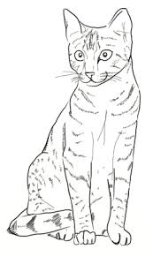](http://www.google.co.uk/imgres?imgurl=http://www.yedraw.com/animals/cat-drawing-5.jpg&imgrefurl=http://www.yedraw.com/how-to-draw-cat.html&h=421&w=250&tbnid=V1JeyKmfbt7P2M:&docid=5C05l6uqBCBzMM&ei=9r_lVZTBGe6f7gaRpKOICQ&tbm=isch&ved=0CHgQMyhOME5qFQoTCJSU96KP1scCFe6P2wodEdIIkQ)[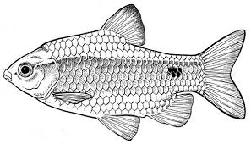](http://www.google.co.uk/imgres?imgurl=https://www.daf.qld.gov.au/__data/assets/image/0010/61777/Fish-Pest-Rosy-Barb-600.jpg&imgrefurl=http://animalzio.com/fish-drawing.htm&h=343&w=600&tbnid=rJUyDgInIxe-qM:&docid=ZN7yEBScOc26nM&ei=qMHlVaaEOKO07gaatYGQBA&tbm=isch&ved=0CD4QMygXMBdqFQoTCKb4jvKQ1scCFSOa2wodmloAQg)[](http://www.google.co.uk/url?sa=i&rct=j&q=&esrc=s&frm=1&source=images&cd=&cad=rja&uact=8&ved=0CAcQjRxqFQoTCLXzs82S1scCFQ9H2wodWq0Hwg&url=http://www.howwhywhere.com/Draw-a-Book/&ei=dMPlVbXpMI-O7Qba2p6QDA&psig=AFQjCNHGxcPGLpqm7XR6xOLeCghx7bLBTw&ust=1441207527287211)**[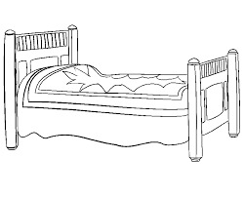](http://www.google.co.uk/imgres?imgurl=http://cdn.kidsroomidea.info/images/beddesign/childrens-beds/drawing-bed-sideways737-x-595-12-kb-gif-x.jpg&imgrefurl=http://beddesign2015.blogspot.com/2015/07/childrens-beds.html&h=595&w=737&tbnid=Cud9F0bVzeL9xM:&docid=BRM-kuXLY2G8KM&ei=I8PlVeD7AseU7QaD9reADQ&tbm=isch&ved=0CGIQMyhfMF84rAJqFQoTCKCZtqaS1scCFUdK2wodA_sN0A)

**Phonological Skills Assessment**

**2. Sound Analysis**

These assessments are *oral*, and test whether a child can ‘hear’ the sounds in words. They assess whether a child can identify and say accurately the separate phonemes in short words.

**Test F**

**Can the child ‘hear’ the first phoneme in a word?**

Procedure

**Say:**

*I’m going to say a word and I want you to tell me what the* first *sound of the word is.*

Emphasise that you want the first sound, and ensure that the child understands what you mean. Use other terminology to make it clear if necessary – ‘the sound at the beginning’, ‘what the word starts with’, etc.

Say:

***f****og* (emphasise but do not distort the /f/)

*The first sound in fog is /f/.* (say the letter sound, not the name)

Say:

*Now listen to* ***m****an* (emphasise but do not distort the /m/)

Say:

*The first sound in man is /m/.* (say the letter sound, not the name)

Continue in the same way with the practice words:

Practice words

***ham sad***

***big jump***

Once the child understands what you are asking her/him to do,

**Say:**

*Now I am going to say some more words, and I want you to tell me the first sound*

Test words

***1. pot 6. girl***

***2. zip 7. jug***

***3. shop 8. do***

***4. big 9. nice***

***5. can 10 race***

Record correct and incorrect responses on the sheet provided.

**Test G**

**Can the child ‘hear’ all three phonemes in a word?**

*Procedure*

**Say:**

*I’m going to say a word and I want you to tell me what the separate* *sounds in the word are.*

Ensure that the child understands what you mean, using other terminology if necessary.

**Say:**

***p****it – the first sound is /p/, the middle sound is /i/ and it ends with /t/.*(say letter sound, not name)

**Say:**

*Now you try. Tell me the sounds in these words*

Practice words

***top can***

***hook fish***

Once the child understands what s/he has to do continue in the same way with the following test words

**Say:**

*Now I am going to say some more words and I want you to tell me all the sounds (in the correct order)*

Test words

***1. pan 4. leg 7. mug 10. bug***

***2. met 5. man 8. win***

***3. chin 6. cot 9. gon(e)***

Record correct and incorrect responses on the sheet provided.

**If the child has made all correct responses on Test G do not give tests H and I**

**Test H**

**Can the child ‘hear’ the final phoneme in a word?**

Procedure

**Say:**

*Now I want you to tell me what the* last *sound in a word is. The last sound in jam is /m/.*

Emphasise that you want the last sound, and ensure that the child understands what you mean. Use other terminology if necessary – ‘the sound at the end’, ‘the last sound you hear’. Give the practice words until the child understands what to do.

Practice words

***miss win***

***well hav(e)***

Once the child understands what you are asking her/him to do,

**Say:**

*Now I am going to say some more words, and I want you to tell me the last sound*

Test words

***1. dog 4. sum 7. hen 10. bell***

***2. tap 5. yes 8. cough***

***3. fat 6. mad 9. leak***

Record correct and incorrect responses on the sheet provided.

**Test I**

**Can the child ‘hear’ the middle (medial) phoneme in a word?**

Procedure

**Say:**

*Now I want you to tell me the sound you can hear in the middle of some words. Try cat* (emphasise but do not distort the /a/)

*The middle sound in cat is /a/.* (say letter sound, not name)

Emphasise that you want the middle sound, and ensure that the child understands what you mean. Use other terminology if necessary to explain. Give the practice words until the child understands what to do.

Practice words

***hop tin***

***pet sad***

Once the child understands what you are asking him/her to do, saying the words normally, continue with the following test words

Test words

***1. map 6. log***

***2. hot 7. hut***

***3. yet 8. dig***

***4. pick 9. pen***

***5. hug 10 sat***

Record correct and incorrect responses on the sheet provided.

**Phonological Skills Assessment**

**3. Awareness of Rhyme**

The following activities assess whether children can generate and/or recognise rhymes. The activities become progressively easier, so you can stop as soon as a child is successful. You should add more explanation at any stage if you think it is needed. It is important that the child understands the task. Always record what the child says.

**Test J**

**Can the child generate rhyming strings?**

*Procedure*

**Say:**

*Now we are going to talk about rhyming words…*

(It is worth using the term because many more children do now know it since the NLS was introduced.) Go on

*….like in the nursery rhyme….Jack and Jill went up the…..*

Allow child to supply the rhyming word – if they can’t, say it for them. **Go on**

*Jill, hill…those words rhyme – they sound a bit the same…they sound the same at the end don’t they. Can you think of any other words that rhyme with Jill and hill? Jill, hill…..*

If the child cannot think of another rhyme, suggest one.

**Say:**

*Jill, hill, pill…. Can you think of another one that rhymes, sounds a bit the same.*

Add some more if there is no response –

**Say:**

*Jill, hill, pill, Bill, mill – they all rhyme – they all sound the same at the end.*

If the child is able to supply a rhyming word,

**Say:**

*Yes that’s right; now let’s change the word – can you think of a word that rhymes with ‘red’? ‘top’?*

By now it will be clear whether the child can supply rhymes fairly easily. If they can do so, it is not necessary to proceed any further.

If s/he cannot find a rhyming word try another word.

**Say:**

*Can you think of any words that rhyme with cat?*

*Cat, bat ………..*

*Can you think of anymore?*

Record the child’s responses on the record sheet.

**Test K**

**Can the child match rhyming pictures?**

Materials

Awareness of Rhyme Sheet.

3 pages of pictures of a range of objects.

Procedures

If the child cannot supply rhymes (Test J), use the Test K sheets of pictures (each has three pictures that rhyme).

**Say:**

*Here are some pictures – some of them rhyme – like Jill, hill. See if you can find the ones that rhyme.*

Show the child one of the sheets of pictures and tell them what the pictures are.

**Say:**

*Can you find the one that rhymes with…..*

Show the child how to look and help them to find the rhyming picture. Then repeat the procedure, to see whether s/he can find the other rhyming pictures.

If the child has difficulty, go on to another of the sheets and name all the pictures first:

Then ask the child to find the pictures that rhyme.

If the child still has difficulty, see if they can discriminate whether pairs of words rhyme when they hear them, e.g. hen/pen, or hen/goat.

**3. Awareness of Rhyme**

**TEST K Matching rhyming picture test**

**[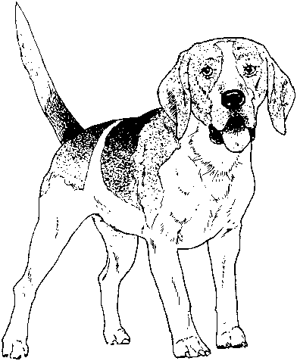](http://www.google.co.uk/url?sa=i&rct=j&q=&esrc=s&frm=1&source=images&cd=&cad=rja&uact=8&ved=0CAcQjRxqFQoTCPbh4OLh7McCFUSP2wodOkwDuA&url=http://froogskid.net/puppy-color-pages/dog-coloring-pages-for-adults/&psig=AFQjCNFzFxc004BLjS5N4wtGt4BB1Pw-iQ&ust=1441984468177687)**

**[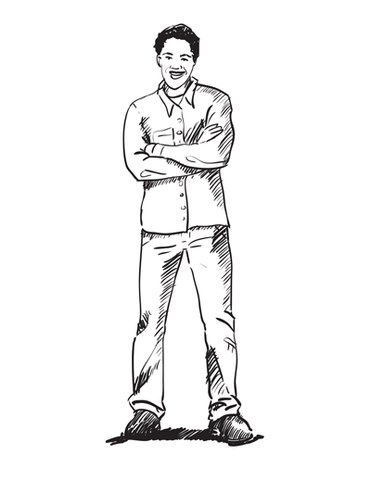](http://www.google.co.uk/url?sa=i&source=imgres&cd=&cad=rja&uact=8&ved=0CAkQjRwwAGoVChMIoJWBupnWxwIVxjLbCh3QEQzW&url=http://sketchbooknation.com/draw-person-standing-armed-crossed-sketchbook-challenge-6/&ei=o8rlVeC3Csbl7AbQo7CwDQ&psig=AFQjCNFsiUwc6rWzCrNoF8EnDZ89aB8mRg&ust=1441209379309910)**

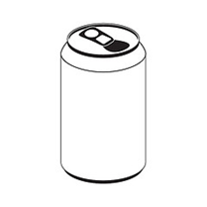

[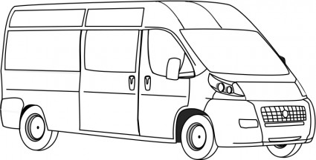](http://www.google.co.uk/url?sa=i&rct=j&q=&esrc=s&frm=1&source=images&cd=&cad=rja&uact=8&ved=0CAcQjRxqFQoTCKme_qni7McCFSss2wodcPEIUw&url=http://all-free-download.com/free-vector/download/van_line_art_117249.html&psig=AFQjCNGKRgf3qGWAhfbN7sAB1iJusCxQww&ust=1441984848641642)

[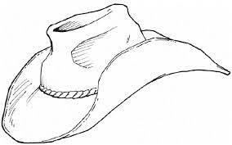](http://www.google.co.uk/imgres?imgurl=http://3.bp.blogspot.com/-uHJPjD-d9a0/VAWy_FcAPkI/AAAAAAAAdhA/zeOlyio5aHs/s1600/hat-of-cowboy.gif&imgrefurl=http://coloursdrawingwallpaper.blogspot.com/2014/09/beautiful-hat-colour-drawing-hd.html&h=808&w=1296&tbnid=CjDAjaIEWykykM:&docid=2drAV-pAzSw_4M&ei=M8zlVcucL6PU7AbNroLABw&tbm=isch&ved=0CFgQMygxMDFqFQoTCIuChPma1scCFSMq2wodTZcAeA)

[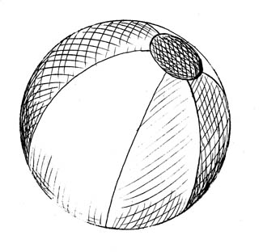](http://www.google.co.uk/url?sa=i&source=imgres&cd=&cad=rja&uact=8&ved=0CAkQjRwwAGoVChMItNSRsOPsxwIVglksCh0hCAUv&url=http://www.artbyrichardmoore.com/stamps.html&psig=AFQjCNF5qnurht4_ZzD9O5ejccDIc3NQnQ&ust=1441985137047748)

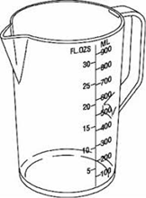

**3. Awareness of Rhyme**

**TEST K Matching rhyming picture test**

**[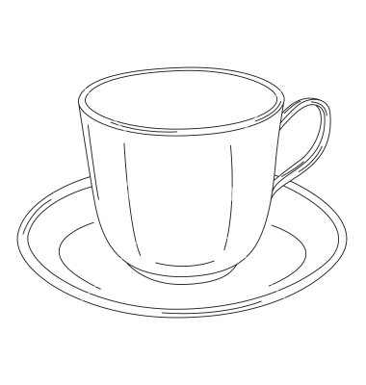](https://www.google.co.uk/url?sa=i&rct=j&q=&esrc=s&frm=1&source=images&cd=&cad=rja&uact=8&ved=0CAcQjRxqFQoTCLaOw7no7McCFQQI2wodffsC8Q&url=https://www.vectorstock.com/royalty-free-vector/coffee-cup-vector-844572&psig=AFQjCNH26eLl_Md1Cs8UuUrmGUgfOEB_UQ&ust=1441986472477068)[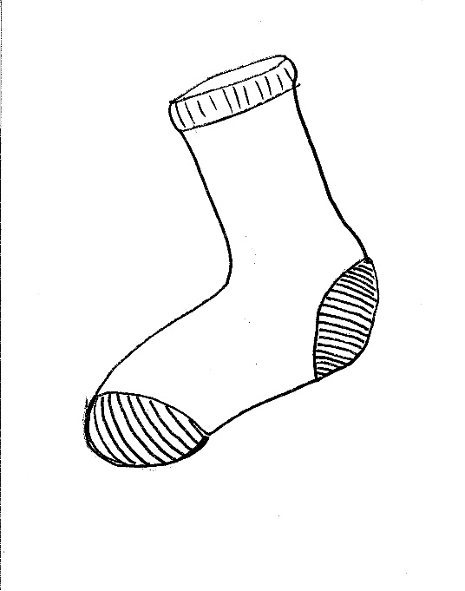](http://www.google.co.uk/url?sa=i&rct=j&q=&esrc=s&frm=1&source=images&cd=&ved=0CAcQjRxqFQoTCI_mmvPm7McCFQxZ2wodqqoPcQ&url=http://www.w12.fr/2/socks-drawing.html&psig=AFQjCNHafHOpdQbGwoBqYoI5lEDRSgNyIw&ust=1441985947961635)[](http://www.google.co.uk/url?sa=i&rct=j&q=&esrc=s&frm=1&source=images&cd=&cad=rja&uact=8&ved=0CAcQjRxqFQoTCLXX_p7m7McCFWhZ2wod3scJkw&url=http://www.istockphoto.com/illustrations/padlock&psig=AFQjCNHZOrfE8gYDGeIp8HL_phDVYvcQFw&ust=1441985869501757)[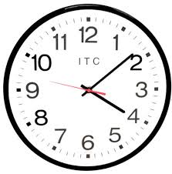](http://www.google.co.uk/imgres?imgurl=http://st.houzz.com/simgs/2d3188a602425ceb_4-5190/modern-clocks.jpg&imgrefurl=http://pixcooler.com/kids%2Bwall%2Bclock&h=514&w=508&tbnid=CSScQCnVi4o2OM:&docid=gTE6CE18nc9qiM&ei=jWLwVazYM6aa7gb7oYJg&tbm=isch&ved=0CGgQMyhBMEFqFQoTCOzSw96z6scCFSaN2wod-5AADA)[](http://www.google.co.uk/url?sa=i&rct=j&q=&esrc=s&frm=1&source=images&cd=&cad=rja&uact=8&ved=0CAcQjRxqFQoTCMbMvraz6scCFYGWFAodIIgLuA&url=http://www.clker.com/clipart-4557.html&bvm=bv.102022582,d.d2s&psig=AFQjCNH89XVm3jKus1FCxL0owE6gyo_gwg&ust=1441903479145511)[](http://www.google.co.uk/url?sa=i&rct=j&q=&esrc=s&frm=1&source=images&cd=&cad=rja&uact=8&ved=0CAcQjRxqFQoTCI_E0tay6scCFcdcFAodpH8E3w&url=http://www.clker.com/clipart-15146.html&bvm=bv.102022582,d.d2s&psig=AFQjCNFL2OcJx1KUeQ4xu_Cvu25LdmOVWw&ust=1441903266620980)**

**3. Awareness of Rhyme**

**TEST K Matching rhyming picture test**

**[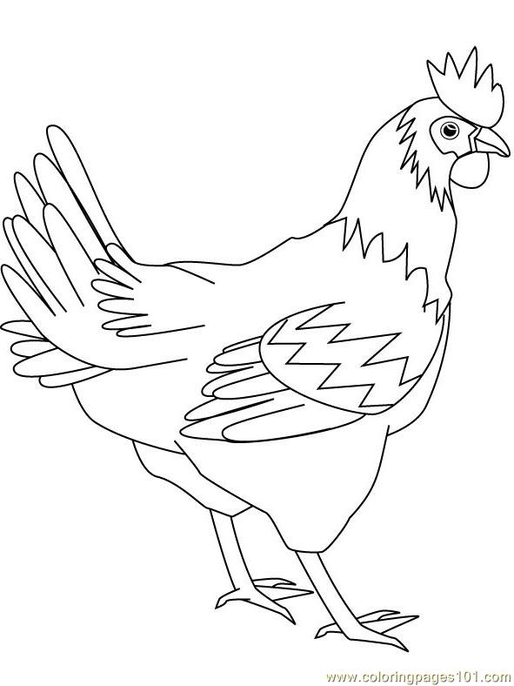](http://www.google.co.uk/url?sa=i&rct=j&q=&esrc=s&frm=1&source=images&cd=&cad=rja&uact=8&ved=0CAcQjRxqFQoTCI3lkaPp7McCFcdL2wodReAFeg&url=http://www.coloringpages101.com/printable_page/69901/Chicks_Hens_and_Roosters/Fighter_Hen&bvm=bv.102022582,d.dmo&psig=AFQjCNGmjlydZXB0hJGEuHP0iNERnQEoEw&ust=1441986656589582)[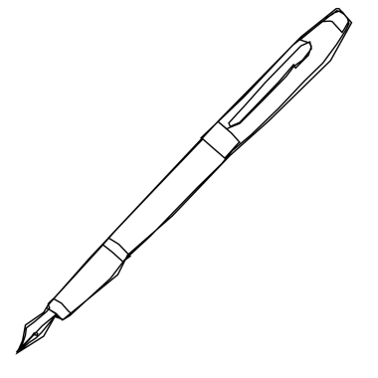](http://www.google.co.uk/url?sa=i&rct=j&q=&esrc=s&frm=1&source=images&cd=&cad=rja&uact=8&ved=0CAcQjRxqFQoTCLLqoefp7McCFWkX2wodP8EPZQ&url=http://www.clipartpanda.com/categories/fountain-pen-drawing&bvm=bv.102022582,d.dmo&psig=AFQjCNFrs9gX9PipV8smQuIgerUuw7ytnw&ust=1441986798503615)**

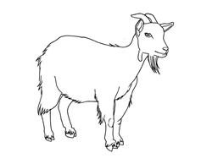**[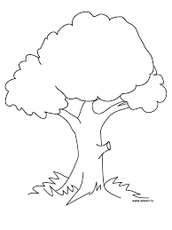](http://www.google.co.uk/imgres?imgurl=http://mkumca.org/wp-content/uploads/2014/10/Tree-coloring-picture.jpg&imgrefurl=http://mkumca.org/tree-coloring-picture-2/&h=1024&w=768&tbnid=q8lZ9ae3H8NLSM:&docid=iU4-1auhiDKVCM&ei=ZbILVvqNJsq1UYuKprAM&tbm=isch&ved=0CGsQMyhHMEdqFQoTCLrU_Na_nsgCFcpaFAodC4UJxg)[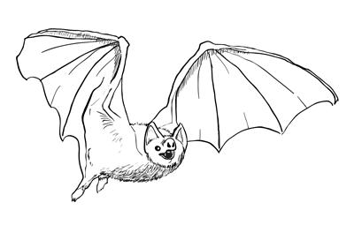](http://www.google.co.uk/url?sa=i&rct=j&q=&esrc=s&frm=1&source=images&cd=&cad=rja&uact=8&ved=0CAcQjRxqFQoTCKHysNjAnsgCFQnvFAodFB0CCA&url=http://sketchbooknation.com/how-to-draw-a-bat-step-by-step/&psig=AFQjCNGA19-_iZF4WBGSPxMaiteLJPTHJA&ust=1443693744011269)[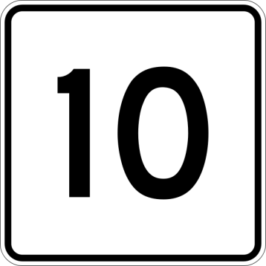](http://www.google.co.uk/url?sa=i&rct=j&q=&esrc=s&frm=1&source=images&cd=&cad=rja&uact=8&ved=0CAcQjRxqFQoTCN7j_ZLq7McCFdIG2wodGe4CVQ&url=http://www.lexicolatry.com/2014/08/deca-10-words-to-do-with-ten.html&bvm=bv.102022582,d.dmo&psig=AFQjCNH0-QxXA7gvfWvYrmfMA-MvXzrlFg&ust=1441986922879961)**

**Literacy Skills Assessment**

**4. Grapheme/Phoneme Knowledge**

The ability to name the letters of the alphabet and to match letters (graphemes) to the sounds (phonemes) that they represent is a very important predictor of literacy skills later on.

Materials

Sheet with letters of the alphabet printed in upper case.

Sheet with letters of the alphabet printed in lower case.

(These can be made into cards)

Grapheme/Phoneme knowledge record sheet.

**Does the child know the names and sounds (phonemes) of the letters of the alphabet?**

Procedure

Show the child the cards in the order on the record sheet.

**Say:**

*I want you to tell me the name of this letter*

When the child has responded

**Say:**

*Now can you tell me the sound that this letter makes?*

Show the child each of the lower case letter cards in turn.

(If the child gets tired or bored you may have to complete this assessment over several sessions.)

**Repeat this procedure for the upper case letters.**

**Procedure**

**Can the child write the correct letter (grapheme) to match a given letter name?**

Without showing the cards to the child

**Say:**

*Now I want you to write down the letter when I say the letter name*

**Can the child write the correct letter (grapheme) to match a given sound (phoneme)?**

Procedure

Without showing the cards to the child

**Say:**

*Now I want you to write down the letter that matches the sound that I say*

Note any hesitancy or incorrect letter formation.

Record responses on the record sheet

Be prepared to complete this assessment over 2 or 3 sessions and not all of it in one session.

**Literacy Skills Assessment**

**4. Grapheme / Phoneme Knowledge Test**

|  |  |  |  |
| --- | --- | --- | --- |
| **A** | **H** | **O** | **V** |
| **B** | **I** | **P** | **W** |
| **C** | **J** | **Q** | **X** |
| **D** | **K** | **R** | **Y** |
| **E** | **L** | **S** | **Z** |
| **F** | **M** | **T** |  |
| **G** | **N** | **U** |  |

**Literacy Skills Assessment**

1. **Grapheme / Phoneme Knowledge Test**

|  |  |  |  |
| --- | --- | --- | --- |
| **a** | **h** | **o** | **v** |
| **b** | **i** | **p** | **w** |
| **c** | **j** | **q** | **x** |
| **d** | **k** | **r** | **y** |
| **e** | **l** | **s** | **z** |
| **f** | **m** | **t** |  |
| **g** | **n** | **u** |  |

**Literacy Skills Assessment**

**5. Basic Word Recognition**

These assessments assess the child’s ability to read the most common words. Additional information can also be gathered including:

* The *strategies* the child has used to read single words
* The *number* of words the pupil recognises at sight and/or decodes
* Strengths or difficulties with phonic or visual strategies
* The pupil’s rate of acquisition and retention of sight vocabulary

Materials

Most high frequency word lists produced are very similar. The lists used here are the ones from *Letters and Sounds*, which were based on the *Children’s Printed Word Database* (2003)*.

(Masterson, J., Stuart, M., Dixon, M. and Lovejoy, S. (2003) Children’s Printed Word Database: Economic and Social Research Council funded project, R00023406)

The Reception words from the *National Literacy Strategy* *(NLS)* are also included, as this has fewer words, and teachers may prefer to use this for pupils who are less confident.

Procedure

Start with Set 1 of the high frequency word recognition list

* Cover all but the first line of words with a piece of card
* Ask the child to read any words they recognise
* If a child is very hesitant and does not seem to recognise any words, offer to point at each word in turn with a pencil and invite the pupil to stop you if s/he thinks s/he might know what a word says
* Move the pencil slowly, and give plenty of time for recall of words like *mum* and *dad*, as theseare quite likely to elicit a response
* Continue a line at a time
* Record *everything* the child says, including incorrect attempts, letter sounds or names and attempts to blend. Try to do this out of the child’s direct vision and be positive about *any* response, whether or not it is correct
* If the child recognises fewer than 15 of the Set 1 word list, do not continue. Otherwise repeat the procedure with Set 2 (you may need to do this over more than one session).

***Recording and Scoring***

As the child reads, try to record what the child does. Does s/he

* Say the letter sounds aloud or under the breath and try to blend them
* Guess using (first) letter(s) as a clue
* Recognise whole words without using phonic strategies
* Attempt many words unsuccessfully, or only make attempts is s/he feels confident

Record all responses

Count the number of words read and record the total and date. Add comments about the strategies used. (It is also useful to note whether pupils respond quickly or takes time to recognise words.)

There is space on each record sheet to note responses and scores on four occasions. Regular testing (perhaps each term) will indicate whether or not words are retained, and help monitor the speed at which pupils acquire new sight vocabulary and phonological skills.

***Phonic strategies***

Children may say letter sounds aloud, or under their breath. Older pupils may even ‘say’ them in their head, and will usually indicate this if asked. If all sounds are written down as the child says them it is often possible to detect whether or not the pupil

* Correctly associates sound and symbol
* Blends sounds properly (some children can say all the sounds correctly, but are unable to blend them together)

Pupils may demonstrate phonological skills orally, or in single word reading, but be unable to use these strategies in continuous text.

NOTE

Assessments of reading strategies used by the pupils also need to be carried out in continuous text.

(Additional assessment using continuous text is essential to evaluate comprehension and other contextual reading skills).

***Word recognition and graphic knowledge/visual cues***

By recording the miscues and noting the speed and confidence of response, it is also possible to get and idea of whether a child;

* Recognises words and/or letters at sight quickly and accurately
* Makes visual errors, eg
  + - Reverses/inverts words or letters
    - Looks at the first letter or beginning of a word and ‘guesses’ the rest
    - Confuses visually similar words or letters, eg t/f, p/b/d, n/u, it/if, come/came, no/on
    - Confuses ‘little’ words eg and/the/it/is/he (more likely in continuous text)

***Suggestions for Recording***

Adopt your own ‘coding’ torecord pupil responses. It can be helpful to indicate letter names by writing the letter with a small horizontal line above:

− − − −

eg. h a v e *indicates that the child says letter names*

and letter sounds with a small v above:

v v v v

eg. h a v e indicates that the child says letter sounds

If sounds are incorrectly blended, indicate this by also recording the word exactly as the child says it eg. wiv for with:

v v v v

eg s t o p = tip indicates that the child says letter

sounds correctly but misreads the word

**5.** **High Frequency Words**

**(NLS Reception Words)**

**Test sheet**

|  |  |  |  |  |  |
| --- | --- | --- | --- | --- | --- |
| I | up | look | we | like | and |
| on | at | for | he | is | said |
| go | you | are | this | going | they |
| away | play | a | am | cat | to |
| come | day | the | dog | big | my |
| mum | no | dad | all | get | In |
| went | was | of | me | she | see |
| it | yes | can |  |  |  |

**5.** **High Frequency Words Set 1**

**Test sheet**

|  |  |  |  |  |
| --- | --- | --- | --- | --- |
| a | an | as | at | if |
| in | is | it | of | off |
| on | can | dad | had | back |
| and | get | big | him | his |
| not | got | up | mum | but |
| the | to |  | no | go |
| into | will | that | this | then |
| them | with | see | for | now |
| down | look | too | he | she |
| we | me | be | was | you |
| they | all | are | my | her |
| went | it’s | from | children | just |
| help | said | have | like | so |
| do | some | come | were | there |
| little | one | when | out | what |
| don’t | old | I’m | by | time |
| house | about | your | day | made |
| came | make | here | saw | very |
| put | oh | their | people | Mr |
| Mrs | looked | called | asked | could |

**5. High Frequency Words Set 2**

**Test sheet**

|  |  |  |  |  |
| --- | --- | --- | --- | --- |
| water | away | good | want | over |
| how | did | man | going | where |
| would | or | took | school | think |
| home | who | didn’t | ran | know |
| bear | can’t | again | cat | long |
| things | new | after | wanted | eat |
| everyone | our | two | has | yes |
| play | take | thought | dog | well |
| find | more | I’ll | round | tree |
| magic | shouted | us | other | food |
| fox | through | way | been | stop |
| must | red | door | right | sea |
| these | began | boy | animals | never |
| next | first | work | lots | need |
| that’s | baby | fish | gave | mouse |
| something | bed | may | still | found |
| live | say | soon | night | narrator |
| small | car | couldn’t | three | head |
| king | town | I’ve | around | every |
| garden | fast | only | many | laughed |

|  |  |  |  |  |
| --- | --- | --- | --- | --- |
| let’s | much | suddenly | told | another |
| great | why | cried | keep | room |
| last | jumped | because | even | am |
| before | gran | clothes | tell | key |
| fun | place | mother | sat | boat |
| window | sleep | feet | morning | queen |
| each | book | its | green | different |
| let | girl | which | inside | run |
| any | under | hat | snow | air |
| trees | bad | tea | top | eyes |
| fell | friends | box | dark | grandad |
| there’s | looking | end | than | best |
| better | hot | sun | across | gone |
| hard | floppy | really | wind | wish |
| eggs | once | please | thing | stopped |
| ever | miss | most | cold | park |
| lived | birds | duck | horse | rabbit |
| white | coming | he’s | river | liked |
| giant | looks | use | along | plants |
| dragon | pulled | we’re | fly | grow |

**5. High Frequency Words Set 2 cont.**

**Test sheet**

**Literacy Skills Assessment**

1. **Recognition of Phonic Patterns in Words and Non-Words.**

These assessments assess the child’s ability to recognise and read phonic letter patterns with words and non-words.

(Non-words are used to prevent the child from recognising the whole word without needing to recognise the phonic pattern.)

Phonics is the ability to link letter-sound knowledge as a reading strategy.

Materials

Phonic Check Sheets 1-4.

Phonic Skills Assessment record sheet.

Procedure

Place a sheet of paper or card over the check sheet so that only one row of boxes shows at a time.

**Say:**

*I am going to show you some words. I want you to try to read them aloud. Some of the words are not real words they are made up words but I want you to try to read them to me as if they are real words.*

* Point to each word by moving a pencil across the row. Make sure you allow the child plenty of time to respond.
* Encourage the child to have a go if s/he seems hesitant.
* Record on the record sheet everything the child says using the suggested coding used for basic word recognition assessment.
* If the child is struggling with the first few words in any group, encourage him/her to attempt any words s/he feels able to.
* You may need to complete the assessment over more than one session

**6. Phonic Check Sheet 1**

**CVC WORDS**

Medial short /a/

|  |  |  |
| --- | --- | --- |
| **pat** | **man** | **bag** |
| **gat** | **fap** | **tam** |

Medial short/e/

|  |  |  |
| --- | --- | --- |
| **wet** | **ten** | **bed** |
| **seg** | **ped** | **rem** |

Medial short/i/

|  |  |  |
| --- | --- | --- |
| **bin** | **hit** | **lip** |
| **nig** | **fim** | **wib** |

Medial short/o/

|  |  |  |
| --- | --- | --- |
| **dog** | **cot** | **hop** |
| **wod** | **lox** | **pon** |

Medial short /u/

|  |  |  |
| --- | --- | --- |
| **gum** | **cup** | **run** |
| **mup** | **dut** | **sub** |

**6.** **Phonic Check Sheet 2**

**/B/P/D/ WORDS**

|  |  |  |
| --- | --- | --- |
| **bid** | **pod** | **bed** |
| **dip** | **pad** | **dub** |
| **dob** | **bup** | **pab** |
| **bod** | **dap** | **pid** |

**CONSONANT DIGRAPHS**

|  |  |  |
| --- | --- | --- |
| **chin** | **such** | **chap** |
| **chup** | **mich** | **toch** |

|  |  |  |
| --- | --- | --- |
| **shop** | **shut** | **fish** |
| **kish** | **nash** | **shog** |

|  |  |  |
| --- | --- | --- |
| **thin** | **with** | **moth** |
| **peth** | **thip** | **theg** |

|  |  |  |
| --- | --- | --- |
| **sack** | **neck** | **duck** |
| **weck** | **bick** | **pock** |

|  |  |  |
| --- | --- | --- |
| **song** | **wing** | **bang** |
| **jing** | **hong** | **pung** |

**6. Phonic Check Sheet 3**

**INITIAL CONSONANT BLENDS**

|  |  |  |
| --- | --- | --- |
| **block** | **drip** | **skip** |
| **frog** | **crab** | **grub** |
| **slip** | **stem** | **swim** |
| **brick** | **glad** | **spot** |
| **twig** | **trim** | **prod** |
| **clap** | **flag** | **snap** |

**FINAL CONSONANT BLENDS**

|  |  |  |
| --- | --- | --- |
| **sift** | **bank** | **hold** |
| **damp** | **kilt** | **rant** |
| **rust** | **fist** | **silk** |
| **wisp** | **task** | **lend** |

**6. Phonic Check Sheet 4**

**VOWEL DIGRAPHS**

|  |  |  |
| --- | --- | --- |
| **rate** | **wipe** | **home** |
| **tube** | **pain** | **peel** |
| **day** | **heat** | **foam** |
| **coil** | **spout** | **hook** |
| **bitter** | **toy** | **hurt** |
| **town** | **dirt** | **field** |
| **moon** | **law** | **ceiling** |
| **newt** | **low** | **part** |
| **learn** | **spy** | **hair** |

**Phonological Skills Record Sheet**

***1. Oral Sound Blending Name Date***

|  |  |  |  |  |  |
| --- | --- | --- | --- | --- | --- |
| Test A. Three phonemes | | | | | |
| Target Word | 🗶✓ | Response | Target Word | 🗶✓ | Response |
| 1. m-a-d |  |  | 6. y-e-s |  |  |
| 2. h-o-p |  |  | 7. j-a-m |  |  |
| 3. g-e-t |  |  | 8. n-o-t |  |  |
| 4. f-u-n |  |  | 9. w-i-n |  |  |
| 5. l-i-d |  |  | 10. h-u-g |  |  |
| TOTAL CORRECT (Max 10) | | | |  |  |

|  |  |  |  |  |  |
| --- | --- | --- | --- | --- | --- |
| Test B. Syllables | | | | | |
| Target Word | 🗶✓ | Response | Target Word | 🗶✓ | Response |
| 1. mon-ster |  |  | 4. croc-o-dile |  |  |
| 2. pen-guin |  |  | 5. te-le-phone |  |  |
| 3. win-dow |  |  |  |  |  |
| TOTAL CORRECT (Max5) | | | |  |  |

|  |  |  |  |  |  |
| --- | --- | --- | --- | --- | --- |
| Test C. Onset and Rime | | | | | |
| Target Word | 🗶✓ | Response | Target Word | 🗶✓ | Response |
| 1. st-op |  |  | 4. m-ake |  |  |
| 2. p-in |  |  | 5. c-ut |  |  |
| 3. t-en |  |  |  |  |  |
| TOTAL CORRECT (Max5) | | | |  |  |

|  |  |  |  |  |  |
| --- | --- | --- | --- | --- | --- |
| Test D. Four/five phonemes | | | | | |
| Target Word | 🗶✓ | Response | Target Word | 🗶✓ | Response |
| 1. f-l-i-p |  |  | 6. s-t-a-m-p |  |  |
| 2. p-r-a-m |  |  | 7. b-l-e-n-d |  |  |
| 3. b-r-ow-n |  |  | 8. c-r-i-s-p |  |  |
| 4. h-e-l-p |  |  | 9. s-p-l-a-t |  |  |
| 5. p-I-n-k |  |  | 10. s-t-r-i-p |  |  |
| TOTAL CORRECT (Max 10) | | | |  |  |

|  |  |  |  |  |  |
| --- | --- | --- | --- | --- | --- |
| Test E. Non-words | | | | | |
| Target Word | 🗶✓ | Response | Target Word | 🗶✓ | Response |
| 1. f-r-i-m |  |  | 6. s-m-o-n-t |  |  |
| 2. t-r-u-ff |  |  | 7. g-l-e-n-d |  |  |
| 3. p-l-ou-t |  |  | 8. p-l-o-s-t |  |  |
| 4. b-i-l-k |  |  | 9. d-r-a-s-k |  |  |
| 5. b-r-a-m-p |  |  | 10. g-l-u-f-t |  |  |
| TOTAL CORRECT (Max 10) | | | |  |  |

**Phonological Skills Record Sheet**

***2. Oral Sound Analysis Name***

***Date***

|  |  |  |  |  |  |
| --- | --- | --- | --- | --- | --- |
| Test F. Initial (first) phonemes | | | | | |
| Target Word | 🗶✓ | Response | Target Word | 🗶✓ | Response |
| 1. pot |  |  | 6. girl |  |  |
| 2. zip |  |  | 7. jug |  |  |
| 3. shop |  |  | 8. do |  |  |
| 4. big |  |  | 9. nice |  |  |
| 5. can |  |  | 10. race |  |  |
| TOTAL CORRECT (Max 10) | | | |  |  |

|  |  |  |  |  |  |
| --- | --- | --- | --- | --- | --- |
| Test G. All three phonemes | | | | | |
| Target Word | 🗶✓ | Response | Target Word | 🗶✓ | Response |
| 1. pan |  |  | 6. cot |  |  |
| 2. met |  |  | 7. mug |  |  |
| 3. chin |  |  | 8. win |  |  |
| 4. leg |  |  | 9. gon(e) |  |  |
| 5. man |  |  | 10. bug |  |  |
| TOTAL CORRECT (Max 10) | | | |  |  |

|  |  |  |  |  |  |
| --- | --- | --- | --- | --- | --- |
| Test H. Final phoneme | | | | | |
| Target Word | 🗶✓ | Response | Target Word | 🗶✓ | Response |
| 1. dog |  |  | 6. mad |  |  |
| 2. tap |  |  | 7. hen |  |  |
| 3. fat |  |  | 8. cough |  |  |
| 4. sum |  |  | 9. leak |  |  |
| 5. yes |  |  | 10. bell |  |  |
| TOTAL CORRECT (Max 10) | | | |  |  |

|  |  |  |  |  |  |
| --- | --- | --- | --- | --- | --- |
| Test I. Medial (middle) vowel | | | | | |
| Target Word | 🗶✓ | Response | Target Word | 🗶✓ | Response |
| 1. map |  |  | 6. log |  |  |
| 2. hot |  |  | 7. hut |  |  |
| 3. yet |  |  | 8. dig |  |  |
| 4. pick |  |  | 9. pen |  |  |
| 5. hug |  |  | 10. sat |  |  |
| TOTAL CORRECT (Max 10) | | | |  |  |

**Phonological Skills Record Sheet**

***3. Awareness of Rhyme Name Date***

|  |  |
| --- | --- |
| Test J. Generating rhyming strings | |
| Target word | Response |
| hill |  |
|  |  |
|  |  |
|  |  |
|  |  |

|  |  |
| --- | --- |
| Test K. Matching rhyming pictures | |
| Target picture | Response |
|  |  |
|  |  |
|  |  |
|  |  |
|  |  |

|  |  |
| --- | --- |
| Test K. Hearing pairs of rhymes (use if child cannot match) | |
| Rhyming Pairs | Response |
|  |  |
|  |  |
|  |  |
|  |  |
|  |  |

***4. Grapheme/Phoneme Knowledge Record Sheet***

**Lower Case Letters**

|  |  |  |  |  |
| --- | --- | --- | --- | --- |
| **Letter** | **Knows sound** | **Knows letter name** | **Can give word beginning with sound** | **Can form letter correctly independently** |
| ***a*** |  |  |  |  |
| ***h*** |  |  |  |  |
| ***o*** |  |  |  |  |
| ***v*** |  |  |  |  |
| ***b*** |  |  |  |  |
| ***i*** |  |  |  |  |
| ***p*** |  |  |  |  |
| ***w*** |  |  |  |  |
| ***c*** |  |  |  |  |
| ***j*** |  |  |  |  |
| ***q*** |  |  |  |  |
| ***x*** |  |  |  |  |
| ***d*** |  |  |  |  |
| ***k*** |  |  |  |  |
| ***r*** |  |  |  |  |
| ***y*** |  |  |  |  |
| ***e*** |  |  |  |  |
| ***l*** |  |  |  |  |
| ***s*** |  |  |  |  |
| ***z*** |  |  |  |  |
| ***f*** |  |  |  |  |
| ***m*** |  |  |  |  |
| ***t*** |  |  |  |  |
| ***g*** |  |  |  |  |
| ***n*** |  |  |  |  |
| ***u*** |  |  |  |  |
| Total | /26 | /26 | /26 | /26 |

**Upper Case Letters**

|  |  |  |  |  |
| --- | --- | --- | --- | --- |
| **Letter** | **Knows sound** | **Knows letter name** | **Can give word beginning with sound** | **Can form letter correctly independently** |
| ***A*** |  |  |  |  |
| ***H*** |  |  |  |  |
| ***O*** |  |  |  |  |
| ***V*** |  |  |  |  |
| ***B*** |  |  |  |  |
| ***I*** |  |  |  |  |
| ***P*** |  |  |  |  |
| ***W*** |  |  |  |  |
| ***C*** |  |  |  |  |
| ***J*** |  |  |  |  |
| ***Q*** |  |  |  |  |
| ***X*** |  |  |  |  |
| ***D*** |  |  |  |  |
| ***K*** |  |  |  |  |
| ***R*** |  |  |  |  |
| ***Y*** |  |  |  |  |
| ***E*** |  |  |  |  |
| ***L*** |  |  |  |  |
| ***S*** |  |  |  |  |
| ***Z*** |  |  |  |  |
| ***F*** |  |  |  |  |
| ***M*** |  |  |  |  |
| ***T*** |  |  |  |  |
| ***G*** |  |  |  |  |
| ***N*** |  |  |  |  |
| ***U*** |  |  |  |  |
| Total | /26 | /26 | /26 | /26 |

**5.Word Recognition**

***NLS* Reception Words**

**Record Sheet**

|  |  |  |  |  |  |  |  |
| --- | --- | --- | --- | --- | --- | --- | --- |
|  | date | date | date |  | date | date | date |
| I |  |  |  | to |  |  |  |
| up |  |  |  | come |  |  |  |
| look |  |  |  | day |  |  |  |
| we |  |  |  | the |  |  |  |
| like |  |  |  | dog |  |  |  |
| and |  |  |  | big |  |  |  |
| on |  |  |  | my |  |  |  |
| at |  |  |  | mum |  |  |  |
| for |  |  |  | no |  |  |  |
| he |  |  |  | dad |  |  |  |
| is |  |  |  | all |  |  |  |
| said |  |  |  | get |  |  |  |
| go |  |  |  | in |  |  |  |
| you |  |  |  | went |  |  |  |
| are |  |  |  | was |  |  |  |
| this |  |  |  | of |  |  |  |
| going |  |  |  | me |  |  |  |
| they |  |  |  | she |  |  |  |
| away |  |  |  | see |  |  |  |
| play |  |  |  | it |  |  |  |
| a |  |  |  | yes |  |  |  |
| am |  |  |  | can |  |  |  |
| cat |  |  |  |  |  |  |  |
|  |  |  |  | Totals | /45 | /45 | /45 |

**5. Word Recognition Set 1**

**Record Sheet**

|  |  |  |  |  |  |  |  |
| --- | --- | --- | --- | --- | --- | --- | --- |
|  | date | date | date |  | date | date | date |
| a |  |  |  | are |  |  |  |
| in |  |  |  | from |  |  |  |
| on |  |  |  | have |  |  |  |
| and |  |  |  | come |  |  |  |
| not |  |  |  | when |  |  |  |
| the |  |  |  | I’m |  |  |  |
| into |  |  |  | your |  |  |  |
| them |  |  |  | here |  |  |  |
| down |  |  |  | their |  |  |  |
| we |  |  |  | called |  |  |  |
| they |  |  |  | at |  |  |  |
| went |  |  |  | of |  |  |  |
| help |  |  |  | had |  |  |  |
| do |  |  |  | him |  |  |  |
| little |  |  |  | mum |  |  |  |
| don’t |  |  |  | no |  |  |  |
| house |  |  |  | this |  |  |  |
| came |  |  |  | for |  |  |  |
| put |  |  |  | he |  |  |  |
| Mrs |  |  |  | was |  |  |  |
| an |  |  |  | my |  |  |  |
| is |  |  |  | children |  |  |  |
| can |  |  |  | like |  |  |  |
| get |  |  |  | were |  |  |  |
| got |  |  |  | out |  |  |  |
| to |  |  |  | by |  |  |  |
| will |  |  |  | day |  |  |  |
| with |  |  |  | saw |  |  |  |
| look |  |  |  | people |  |  |  |
| me |  |  |  | asked |  |  |  |
| all |  |  |  | if |  |  |  |
| It’s |  |  |  | off |  |  |  |
| said |  |  |  | back |  |  |  |
| some |  |  |  | his |  |  |  |
| one |  |  |  | but |  |  |  |
| old |  |  |  | go |  |  |  |
| about |  |  |  | then |  |  |  |
| make |  |  |  | now |  |  |  |
| oh |  |  |  | she |  |  |  |
| looked |  |  |  | you |  |  |  |
| as |  |  |  | her |  |  |  |
| it |  |  |  | just |  |  |  |
| dad |  |  |  | so |  |  |  |
| big |  |  |  | there |  |  |  |
| up |  |  |  | what |  |  |  |
| I |  |  |  | time |  |  |  |
| that |  |  |  | made |  |  |  |
| see |  |  |  | very |  |  |  |
| too |  |  |  | Mr |  |  |  |
| be |  |  |  | could |  |  |  |

**5. Word Recognition Set 2**

**Record Sheet**

|  |  |  |  |  |  |  |  |
| --- | --- | --- | --- | --- | --- | --- | --- |
|  | date | date | date |  | date | date | date |
| water |  |  |  | way |  |  |  |
| how |  |  |  | door |  |  |  |
| would |  |  |  | boy |  |  |  |
| home |  |  |  | work |  |  |  |
| bear |  |  |  | fish |  |  |  |
| things |  |  |  | may |  |  |  |
| everyone |  |  |  | soon |  |  |  |
| play |  |  |  | couldn’t |  |  |  |
| find |  |  |  | I’ve |  |  |  |
| magic |  |  |  | only |  |  |  |
| fox |  |  |  | want |  |  |  |
| must |  |  |  | going |  |  |  |
| these |  |  |  | school |  |  |  |
| next |  |  |  | ran |  |  |  |
| that’s |  |  |  | cat |  |  |  |
| something |  |  |  | wanted |  |  |  |
| live |  |  |  | has |  |  |  |
| small |  |  |  | dog |  |  |  |
| king |  |  |  | round |  |  |  |
| garden |  |  |  | other |  |  |  |
| away |  |  |  | been |  |  |  |
| did |  |  |  | right |  |  |  |
| or |  |  |  | animals |  |  |  |
| who |  |  |  | lots |  |  |  |
| can’t |  |  |  | gave |  |  |  |
| new |  |  |  | still |  |  |  |
| our |  |  |  | night |  |  |  |
| take |  |  |  | three |  |  |  |
| more |  |  |  | around |  |  |  |
| shouted |  |  |  | many |  |  |  |
| through |  |  |  | over |  |  |  |
| red |  |  |  | where |  |  |  |
| began |  |  |  | think |  |  |  |
| first |  |  |  | know |  |  |  |
| baby |  |  |  | long |  |  |  |
| bed |  |  |  | eat |  |  |  |
| say |  |  |  | yes |  |  |  |
| car |  |  |  | well |  |  |  |
| town |  |  |  | tree |  |  |  |
| fast |  |  |  | food |  |  |  |
| good |  |  |  | stop |  |  |  |
| man |  |  |  | sea |  |  |  |
| took |  |  |  | never |  |  |  |
| didn’t |  |  |  | need |  |  |  |
| again |  |  |  | mouse |  |  |  |
| after |  |  |  | found |  |  |  |
| two |  |  |  | narrator |  |  |  |
| thought |  |  |  | head |  |  |  |
| I’ll |  |  |  | every |  |  |  |
| us |  |  |  | laughed |  |  |  |

**5. Word Recognition Set 2 cont.**

**Record Sheet**

|  |  |  |  |  |  |  |  |
| --- | --- | --- | --- | --- | --- | --- | --- |
|  | date | date | date |  | date | date | date |
| let’s |  |  |  | box |  |  |  |
| great |  |  |  | end |  |  |  |
| last |  |  |  | sun |  |  |  |
| before |  |  |  | really |  |  |  |
| fun |  |  |  | please |  |  |  |
| window |  |  |  | most |  |  |  |
| each |  |  |  | duck |  |  |  |
| let |  |  |  | he’s |  |  |  |
| any |  |  |  | use |  |  |  |
| trees |  |  |  | we’re |  |  |  |
| fell |  |  |  | told |  |  |  |
| there’s |  |  |  | keep |  |  |  |
| better |  |  |  | even |  |  |  |
| hard |  |  |  | tell |  |  |  |
| eggs |  |  |  | sat |  |  |  |
| ever |  |  |  | morning |  |  |  |
| lived |  |  |  | green |  |  |  |
| white |  |  |  | inside |  |  |  |
| giant |  |  |  | snow |  |  |  |
| dragon |  |  |  | top |  |  |  |
| much |  |  |  | dark |  |  |  |
| why |  |  |  | than |  |  |  |
| jumped |  |  |  | across |  |  |  |
| gran |  |  |  | wind |  |  |  |
| place |  |  |  | thing |  |  |  |
| sleep |  |  |  | cold |  |  |  |
| book |  |  |  | horse |  |  |  |
| girl |  |  |  | river |  |  |  |
| under |  |  |  | along |  |  |  |
| bad |  |  |  | fly |  |  |  |
| friends |  |  |  | another |  |  |  |
| looking |  |  |  | room |  |  |  |
| hot |  |  |  | am |  |  |  |
| floppy |  |  |  | key |  |  |  |
| once |  |  |  | boat |  |  |  |
| miss |  |  |  | queen |  |  |  |
| birds |  |  |  | different |  |  |  |
| coming |  |  |  | run |  |  |  |
| looks |  |  |  | air |  |  |  |
| pulled |  |  |  | eyes |  |  |  |
| suddenly |  |  |  | grandad |  |  |  |
| cried |  |  |  | best |  |  |  |
| because |  |  |  | gone |  |  |  |
| clothes |  |  |  | wish |  |  |  |
| mother |  |  |  | stopped |  |  |  |
| feet |  |  |  | park |  |  |  |
| its |  |  |  | rabbit |  |  |  |
| which |  |  |  | liked |  |  |  |
| hat |  |  |  | plants |  |  |  |
| tea |  |  |  | grow |  |  |  |

**Literacy Skills Assessment**

**6. Phonic Record Sheet**

***Name Date Class Year***

|  |  |  |  |  |  |
| --- | --- | --- | --- | --- | --- |
| CVC Words | | | | | |
| Target Word | 🗶✓ | Response | Target Word | 🗶✓ | Response |
| pat |  |  | gat |  |  |
| man |  |  | fap |  |  |
| bag |  |  | tam |  |  |
| wet |  |  | seg |  |  |
| ten |  |  | ped |  |  |
| bed |  |  | rem |  |  |
| bin |  |  | nig |  |  |
| hit |  |  | fim |  |  |
| lip |  |  | wib |  |  |
| dog |  |  | wod |  |  |
| cot |  |  | lox |  |  |
| hop |  |  | pon |  |  |
| gum |  |  | mup |  |  |
| cup |  |  | dut |  |  |
| run |  |  | sub |  |  |

|  |  |  |  |  |  |
| --- | --- | --- | --- | --- | --- |
| BPD Words | | | | | |
| Target Word | 🗶✓ | Response | Target Word | 🗶✓ | Response |
| bid |  |  | dob |  |  |
| pod |  |  | bup |  |  |
| bed |  |  | pab |  |  |
| dip |  |  | bod |  |  |
| pad |  |  | dap |  |  |
| dub |  |  | pid |  |  |

|  |  |  |  |  |  |
| --- | --- | --- | --- | --- | --- |
| Consonant Digraphs | | | | | |
| Target Word | 🗶✓ | Response | Target Word | 🗶✓ | Response |
| chin |  |  | chup |  |  |
| such |  |  | mich |  |  |
| chap |  |  | toch |  |  |
| shop |  |  | kish |  |  |
| shut |  |  | nash |  |  |
| fish |  |  | shog |  |  |
| thin |  |  | peth |  |  |
| with |  |  | thip |  |  |
| moth |  |  | theg |  |  |
| sack |  |  | weck |  |  |
| neck |  |  | bick |  |  |
| duck |  |  | pock |  |  |
| song |  |  | jing |  |  |
| wing |  |  | hong |  |  |
| bang |  |  | pung |  |  |

|  |  |  |  |  |  |
| --- | --- | --- | --- | --- | --- |
| Initial Consonant Blends | | | | | |
| Target Word | 🗶✓ | Response | Target Word | 🗶✓ | Response |
| block |  |  | frog |  |  |
| drip |  |  | crab |  |  |
| skip |  |  | grub |  |  |
| slip |  |  | brick |  |  |
| stem |  |  | glad |  |  |
| swim |  |  | spot |  |  |
| twig |  |  | clap |  |  |
| trim |  |  | flag |  |  |
| prod |  |  | snap |  |  |
|  |  |  |  |  |  |

|  |  |  |  |  |  |
| --- | --- | --- | --- | --- | --- |
| Final Consonant Blends | | | | | |
| Target Word | 🗶✓ | Response | Target Word | 🗶✓ | Response |
| sift |  |  | damp |  |  |
| bank |  |  | kilt |  |  |
| hold |  |  | rant |  |  |
| rust |  |  | wisp |  |  |
| fist |  |  | task |  |  |
| silk |  |  | lend |  |  |

|  |  |  |  |  |  |
| --- | --- | --- | --- | --- | --- |
| Vowel Digraphs | | | | | |
| Target Word | 🗶✓ | Response | Target Word | 🗶✓ | Response |
| rate |  |  | hair |  |  |
| wipe |  |  | tube |  |  |
| home |  |  | pain |  |  |
| day |  |  | peel |  |  |
| heat |  |  | coil |  |  |
| foam |  |  | spout |  |  |
| bitter |  |  | hook |  |  |
| toy |  |  | town |  |  |
| hurt |  |  | dirt |  |  |
| moon |  |  | field |  |  |
| law |  |  | newt |  |  |
| ceiling |  |  | low |  |  |
| learn |  |  | part |  |  |
| spy |  |  |  |  |  |

**Literacy Assessment Pack**  Name:

**Summary Sheet**

**Sections 1-3: Phonological Skills**

|  |  |
| --- | --- |
| **Test** | **Achieved (date)** |
| ***1. Oral Sound Blending*** | |
| A: Three phonemes |  |
| B: Syllables | These should be ticked and dated when the child has demonstrated that they are secure in each skill. |
| C: Onset and rime |  |
| D: Four/five phonemes |  |
| E: Non-words |  |
| ***2. Oral Sound Analysis*** | |
| F: Initial phonemes |  |
| G: All three phonemes |  |
| H: Final phoneme |  |
| I: Medial vowel |  |
| ***3. Awareness of Rhyme*** | |
| J: Generating rhyming strings |  |
| K: Matching rhyming pictures |  |
| L: Identifying non-rhyming pictures |  |

**Section 4: Grapheme/Phoneme Knowledge**

(please enter each date that the child is tested and their score out of 52 for being able to say the letter sound and name)

|  |  |  |  |  |  |  |
| --- | --- | --- | --- | --- | --- | --- |
| **Date** |  |  |  |  |  |  |
| Lower case | /52 | /52 | /52 | /52 | /52 | /52 |
| Upper case | /52 | /52 | /52 | /52 | /52 | /52 |

**Section 5: Word Recognition**

(please record how many words the child is able to read from each list and the date of testing – refer to each child’s assessment pack for the words he/she was unable to recognise)

|  |  |  |  |  |  |  |  |  |  |  |  |
| --- | --- | --- | --- | --- | --- | --- | --- | --- | --- | --- | --- |
| **Date** |  |  |  |  |  |  |  |  |  |  |  |
| HF Words  NLS YR list | /45 | /45 | /45 | /45 | /45 | /45 | /45 | /45 | /45 | /45 | /45 |
| HF Words  Set 1 | /100 | /100 | /100 | /100 | /100 | /100 | /100 | /100 | /100 | /100 | /100 |
| HF Words  Set 2 | /200 | /200 | /200 | /200 | /200 | /200 | /200 | /200 | /200 | /200 | /200 |

**Section 6: Phonics**

|  |  |
| --- | --- |
| **Test** | **Achieved (date)** |
| CVC words |  |
| CVC non-words |  |
| BPD words and non-words |  |
| Consonant digraph words |  |
| Consonant digraph non-words |  |
| Initial consonant blends |  |
| final consonant blends |  |
| vowel digraphs |  |

**LITERACY ASSESSMENT PACK - COHORT RECORD SHEET**

|  |  |  |  |  |  |  |  |  |  |  |  |  |  |  |  |  |  |  |  |  |  |  |  |  |  |  |  |  |  |  |  |  |  |  |  |  |  |  |  |  |  |  |  |
| --- | --- | --- | --- | --- | --- | --- | --- | --- | --- | --- | --- | --- | --- | --- | --- | --- | --- | --- | --- | --- | --- | --- | --- | --- | --- | --- | --- | --- | --- | --- | --- | --- | --- | --- | --- | --- | --- | --- | --- | --- | --- | --- | --- |
| Name | Oral Sound Blending | | | | | | | | | | | | | | | Oral Sound Analysis | | | | | | | | | | | | | | | | Awareness of Rhyme | | | | | | | | | | | |
| Test A: /10 | | | Test B:  /5 | | | Test C:  /5 | | | Test D:  /10 | | | Test E:  /10 | | | Test F:  /10 | | | | Test G:  /10 | | | | Test H:  /10 | | | | Test I:  /10 | | | | Test J:  Y/N | | | | Test K:  Y/N | | | | Test L:  Y/N | | | |
| 1 | 2 | 3 | 1 | 2 | 3 | 1 | 2 | 3 | 1 | 2 | 3 | 1 | 2 | 3 | | 1 | 2 | 3 | | 1 | 2 | 3 | | 1 | 2 | 3 | | 1 | 2 | 3 | | 1 | 2 | 3 | | 1 | 2 | 3 | | 1 | 2 | 3 | |
|  |  |  |  |  |  |  |  |  |  |  |  |  |  |  |  | |  |  |  | |  |  |  | |  |  |  | |  |  |  | |  |  |  | |  |  |  | |  |  |  | |
|  |  |  |  |  |  |  |  |  |  |  |  |  |  |  |  | |  |  |  | |  |  |  | |  |  |  | |  |  |  | |  |  |  | |  |  |  | |  |  |  | |
|  |  |  |  |  |  |  |  |  |  |  |  |  |  |  |  | |  |  |  | |  |  |  | |  |  |  | |  |  |  | |  |  |  | |  |  |  | |  |  |  | |
|  |  |  |  |  |  |  |  |  |  |  |  |  |  |  |  | |  |  |  | |  |  |  | |  |  |  | |  |  |  | |  |  |  | |  |  |  | |  |  |  | |
|  |  |  |  |  |  |  |  |  |  |  |  |  |  |  |  | |  |  |  | |  |  |  | |  |  |  | |  |  |  | |  |  |  | |  |  |  | |  |  |  | |
|  |  |  |  |  |  |  |  |  |  |  |  |  |  |  |  | |  |  |  | |  |  |  | |  |  |  | |  |  |  | |  |  |  | |  |  |  | |  |  |  | |
|  |  |  |  |  |  |  |  |  |  |  |  |  |  |  |  | |  |  |  | |  |  |  | |  |  |  | |  |  |  | |  |  |  | |  |  |  | |  |  |  | |
|  |  |  |  |  |  |  |  |  |  |  |  |  |  |  |  | |  |  |  | |  |  |  | |  |  |  | |  |  |  | |  |  |  | |  |  |  | |  |  |  | |
|  |  |  |  |  |  |  |  |  |  |  |  |  |  |  |  | |  |  |  | |  |  |  | |  |  |  | |  |  |  | |  |  |  | |  |  |  | |  |  |  | |
|  |  |  |  |  |  |  |  |  |  |  |  |  |  |  |  | |  |  |  | |  |  |  | |  |  |  | |  |  |  | |  |  |  | |  |  |  | |  |  |  | |
|  |  |  |  |  |  |  |  |  |  |  |  |  |  |  |  | |  |  |  | |  |  |  | |  |  |  | |  |  |  | |  |  |  | |  |  |  | |  |  |  | |
|  |  |  |  |  |  |  |  |  |  |  |  |  |  |  |  | |  |  |  | |  |  |  | |  |  |  | |  |  |  | |  |  |  | |  |  |  | |  |  |  | |
|  |  |  |  |  |  |  |  |  |  |  |  |  |  |  |  | |  |  |  | |  |  |  | |  |  |  | |  |  |  | |  |  |  | |  |  |  | |  |  |  | |
|  |  |  |  |  |  |  |  |  |  |  |  |  |  |  |  | |  |  |  | |  |  |  | |  |  |  | |  |  |  | |  |  |  | |  |  |  | |  |  |  | |
|  |  |  |  |  |  |  |  |  |  |  |  |  |  |  |  | |  |  |  | |  |  |  | |  |  |  | |  |  |  | |  |  |  | |  |  |  | |  |  |  | |
|  |  |  |  |  |  |  |  |  |  |  |  |  |  |  |  | |  |  |  | |  |  |  | |  |  |  | |  |  |  | |  |  |  | |  |  |  | |  |  |  | |
|  |  |  |  |  |  |  |  |  |  |  |  |  |  |  |  | |  |  |  | |  |  |  | |  |  |  | |  |  |  | |  |  |  | |  |  |  | |  |  |  | |

|  |  |  |  |  |  |  |  |  |  |  |  |  |  |  |  |  |  |  |  |  |  |  |  |  |  |  |  |  |  |  |  |  |  |  |  |  |  |
| --- | --- | --- | --- | --- | --- | --- | --- | --- | --- | --- | --- | --- | --- | --- | --- | --- | --- | --- | --- | --- | --- | --- | --- | --- | --- | --- | --- | --- | --- | --- | --- | --- | --- | --- | --- | --- | --- |
| Name | Grapheme/Phoneme Knowledge | | | | | | | | | | | | Word Recognition | | | | | | CVC words:  /30 | | | BPD  words:  /12 | | | Conso  -nant  Digraphs:  /30 | | | Initial  Consonant  Blends:  /18 | | | Final  Conson-ant  Blends:  /12 | | | | Vowel Digraphs  /27 | | |
| Lower Case | | | | | | Upper Case | | | | | | NLS list  /45 | | | Sets 1-3  300 | | |
| Name:  /26 | | | Sound:  /26 | | | Name:  /26 | | | Sound:  /26 | | |
| 1 | 2 | 3 | 1 | 2 | 3 | 1 | 2 | 3 | 1 | 2 | 3 | 1 | 2 | 3 | 1 | 2 | 3 | 1 | 2 | 3 | 1 | 2 | 3 | 1 | 2 | 3 | 1 | 2 | 3 | | 1 | 2 | 3 | 1 | 2 | 3 |
|  |  |  |  |  |  |  |  |  |  |  |  |  |  |  |  |  |  |  |  |  |  |  |  |  |  |  |  |  |  |  | |  |  |  |  |  |  |
|  |  |  |  |  |  |  |  |  |  |  |  |  |  |  |  |  |  |  |  |  |  |  |  |  |  |  |  |  |  |  | |  |  |  |  |  |  |
|  |  |  |  |  |  |  |  |  |  |  |  |  |  |  |  |  |  |  |  |  |  |  |  |  |  |  |  |  |  |  | |  |  |  |  |  |  |
|  |  |  |  |  |  |  |  |  |  |  |  |  |  |  |  |  |  |  |  |  |  |  |  |  |  |  |  |  |  |  | |  |  |  |  |  |  |
|  |  |  |  |  |  |  |  |  |  |  |  |  |  |  |  |  |  |  |  |  |  |  |  |  |  |  |  |  |  |  | |  |  |  |  |  |  |
|  |  |  |  |  |  |  |  |  |  |  |  |  |  |  |  |  |  |  |  |  |  |  |  |  |  |  |  |  |  |  | |  |  |  |  |  |  |
|  |  |  |  |  |  |  |  |  |  |  |  |  |  |  |  |  |  |  |  |  |  |  |  |  |  |  |  |  |  |  | |  |  |  |  |  |  |
|  |  |  |  |  |  |  |  |  |  |  |  |  |  |  |  |  |  |  |  |  |  |  |  |  |  |  |  |  |  |  | |  |  |  |  |  |  |
|  |  |  |  |  |  |  |  |  |  |  |  |  |  |  |  |  |  |  |  |  |  |  |  |  |  |  |  |  |  |  | |  |  |  |  |  |  |
|  |  |  |  |  |  |  |  |  |  |  |  |  |  |  |  |  |  |  |  |  |  |  |  |  |  |  |  |  |  |  | |  |  |  |  |  |  |
|  |  |  |  |  |  |  |  |  |  |  |  |  |  |  |  |  |  |  |  |  |  |  |  |  |  |  |  |  |  |  | |  |  |  |  |  |  |
|  |  |  |  |  |  |  |  |  |  |  |  |  |  |  |  |  |  |  |  |  |  |  |  |  |  |  |  |  |  |  | |  |  |  |  |  |  |
|  |  |  |  |  |  |  |  |  |  |  |  |  |  |  |  |  |  |  |  |  |  |  |  |  |  |  |  |  |  |  | |  |  |  |  |  |  |
|  |  |  |  |  |  |  |  |  |  |  |  |  |  |  |  |  |  |  |  |  |  |  |  |  |  |  |  |  |  |  | |  |  |  |  |  |  |
|  |  |  |  |  |  |  |  |  |  |  |  |  |  |  |  |  |  |  |  |  |  |  |  |  |  |  |  |  |  |  | |  |  |  |  |  |  |
|  |  |  |  |  |  |  |  |  |  |  |  |  |  |  |  |  |  |  |  |  |  |  |  |  |  |  |  |  |  |  | |  |  |  |  |  |  |
|  |  |  |  |  |  |  |  |  |  |  |  |  |  |  |  |  |  |  |  |  |  |  |  |  |  |  |  |  |  |  | |  |  |  |  |  |  |