Pre-school and Primary School Stories

Stories with deaf characters wearing hearing aids

 | Title | Overview
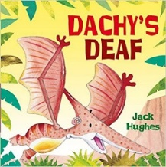 | Dachy’s Deaf  Author – Jack Hughes | Dachy wears a hearing aid. One day, when his hearing aid is off, Dachy falls asleep and ends up floating down the river towards a waterfall and a hungry crocodile. Can his friends rescue him in time?
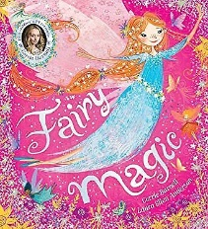 | Fairy Magic  Author - Cerri Burnell | Isabelle has discovered a fairy called Summer-Blue in a hidden magical world at the bottom of her garden... But will she be able to convince her brothers and sisters? A charming story about fairies, the changing seasons and a little girl who is deaf.
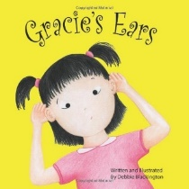 | Gracie’s Ears  Author – Debbie Blackington | Based on a true story about a little girl who does not realise that her ears are not working like most people’s do. When her family search for answers, she discovers the wonder of hearing aids and the sounds of the world.
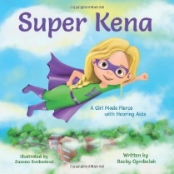 | Super Kena: A Girl Made Fierce with Hearing Aids  Author – Becky Cymbalak | When kids at school make fun of her hearing aids, she gets a super idea. Super Kena will gather her differently-abled classmates to create a team of "super heroes". Together, they will use their super powers to make a difference in the world.
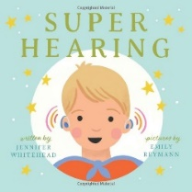 | Super Hearing (Super Book Series)  Author – Jennifer Whitehead | Super Hearing is a celebration of life with hearing aids, here to educate and encourage acceptance in every form.
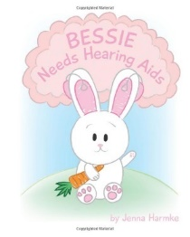 | Bessie Needs Hearing Aids  Author – Jenna Harmke | "Bessie Needs Hearing Aids" is a children's book that will help children with hearing loss understand the process, and that they are not alone.
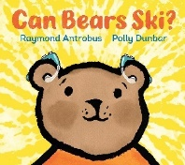 | Can Bears Ski  Author – Raymond Antrobus | Boy Bear keeps hearing the question, “Can Bears ski?” What does it mean? With the support of Dad Bear, Boy Bear visits an audiologist and, eventually, he gets hearing aids. Suddenly, he understands the question everyone has been asking him: "CAN YOU HEAR ME?"
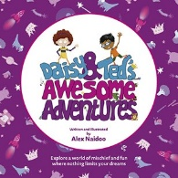 | Daisy and Ted’s Awesome Adventures (Available from the NCDS Website)  Author – Alex Naidoo | Daisy and Ted’s Awesome Adventures is an exciting story, aimed at four to seven year olds, that follows Daisy, a deaf girl who wears a hearing aid, on imaginative adventures with new friend Ted.
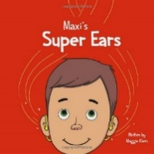 | Maxi’s Super Ears  Author – Maggie Klein | This is the story of the time a brave, young boy got his first set of hearing aids. Join Maxi on his journey into the world of hearing, where he learns to accept each other for what makes us unique.
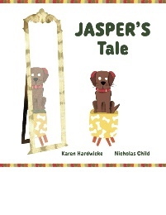 | Jasper’s Tale  Author – Karen Hardwick / Nicolas Child | Jasper is a puppy that is deaf. Despite his moulds having bones on them, he does not like his hearing aids… This is the story of how one cheeky puppy discovers that he likes his hearing aids after all.
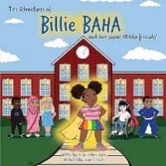 | Billie BAHA  Author – Jessica Jordan Hogan | My name is Billie. I'm four years old and I am also Hard of Hearing. I have bilateral hearing loss due to Microtia. Microtia is a congenital condition of a little or missing outer ear. I wear my BAHA to be able to hear the world.
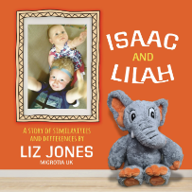 | Isaac & Lilah: A story of similarities and differences  Author – Liz Jones | This book was written for young children with microtia to help them to become aware of their little ears in a positive way, by looking at similarities and differences between themselves and others.

Stories with deaf characters wearing Cochlear Implants

 | Title | Overview
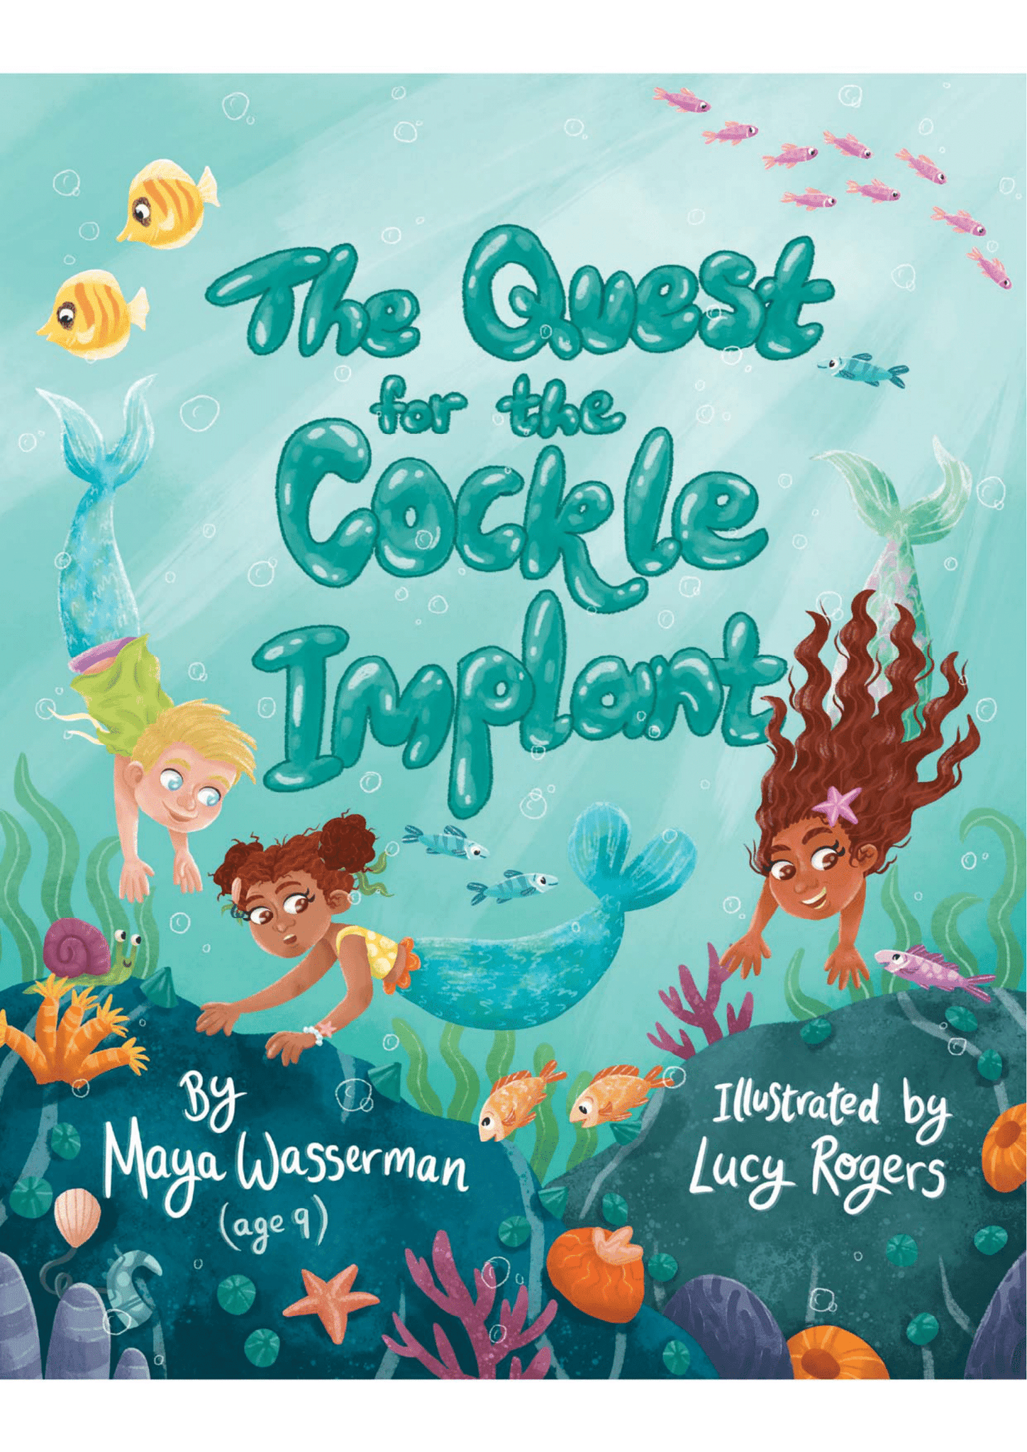 | The Quest for the Cockle Implant  (Available from the NCDS Website)  Author – Maya Wasserman (Aged 9) | When deaf mermaid Angel loses one of her cockle implants, she and her sister go on an exciting adventure through the sea to find it. Using sign language to communicate, their adventure brings them face-to-face with a monstrous Merkitty.
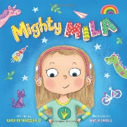 | Mighty Mila  Author – Katie Petruziello | Readers of all ages will love Mila’s spitfire personality and imaginative approach to overcoming obstacles, and will cheer her on as she uses her creativity, her willpower, and even her new cochlear implant hearing devices to face down challenges.
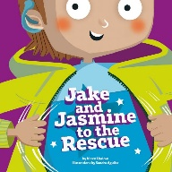 | Jake and Jasmine to the Rescue  (Available from the NCDS Website)  Author – Karen Harlow | When Jake returns to his superhero school after the summer, he finds out that Tilly, the school’s tortoise, has gone missing. Jake & Jasmine to the Rescue stars Jake, who is deaf and wears a cochlear implant.
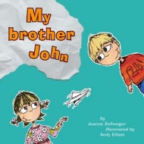 | My Brother John  Author – Joanna Zelwegger | This story reveals some basics about cochlear implants and deaf awareness from a child’s perspective.
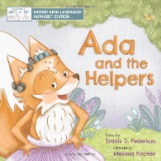 | Ada and the Helpers: British Sign Language Alphabet  Author – Travis Peterson | Ada is a dancing, deaf fox with cochlear implants who loves to help others. On her way to dance in a talent show one day, she meets three creatures who are each facing a physical challenge of their own.
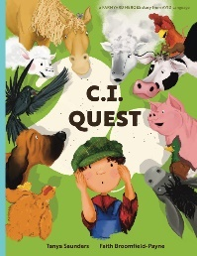 | C.I. Quest  Author – Tanya Saunders | A tale of cochlear implants lost and found on the farm (the young farmer has hearing loss), told through rhyming verse packed with 'learning to listen' animal sounds for early learners.

Stories which include Sign Language

 | Title | Overview
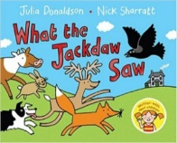 | What the Jackdaw Saw  Author – Julia Donaldson | A highly entertaining book with an inclusive cast of characters, introducing sign language to all children.
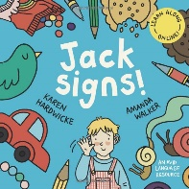 | Jack signs!  Jack signs colours!  Jack signs farm animals!  Author – Karen Hardwicke | Based on a true story, Jack Signs! is the heart-warming story of a little boy who is deaf, his typically hearing sister and their Mum. When his Mum discovers a book of sign language, their family life is transformed and Jack blossoms with his new-found communication skills.
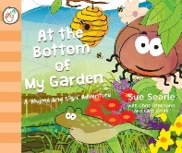 | At the Bottom of My Garden  Author – Sue Searle | At the Bottom of My Garden captures the awe and wonder of childhood explorations whilst supporting emerging literacy and language skills with the addition of key BSL signs to enable little ones to retain and recall information more easily.
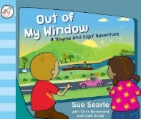 | Out of My Window  Author – Sue Searle | Out of My Window is a glorious transport themed I-spy journey for little ones and accompanies the rhyming text with easy to follow British Sign Language signs.
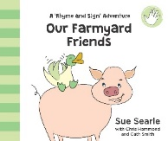 | Our Farmyard Friends  Author – Sue Searle | Meet new farmyard friends as they clamber on board the tractor.... there's a tired old sheep, a muddy pig and even a hen in a hurry! Accompanied by British Sign Language Graphics.
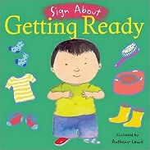 | Sign About – Getting Ready  Sign About – Meal Time  Sign About – Going Out  Author – Anthony Lewis | These signing guides introduce signs for a variety of everyday activities, from getting up in the morning to going to the park. Make signing a natural part of your everyday communication.
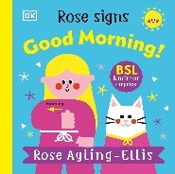 | Rose signs Good Morning!  Rose signs How Do You Feel?  Rose signs Please and Thank you!  Author – Rose Ayling-Ellis | Join Rose and Kitten Casper in this early morning story for 0-5 year olds and learn to sign along the way. Every page shows Baby Rose introducing a new sign to her Kitten Casper.

Stories which include deaf characters (not about deafness)

 | Title | Overview
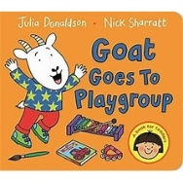 | Goat Goes to Playgroup  Author – Julia Donaldson | The illustration of the monkey shows him wearing a hearing aid – it’s not a theme of the story, just a subtle message that seeing people with hearing aids is not unusual.
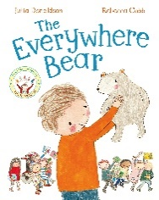 | The Everywhere Bear  Author – Julia Donaldson | The Everywhere Bear has a wonderful time with the children in Class One, but one day he gets more than he bargained for when he falls unnoticed from a backpack and embarks on his own big adventure! One of the characters wears a hearing aid.
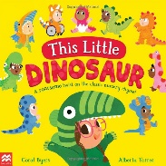 | This Little Dinosaur  Author – Coral Byers | Follow ten little dinosaurs as they dress up, explore and more in this fun preschool counting book based on the classic nursery rhyme This Little Piggy. One of the characters wears a hearing aid.
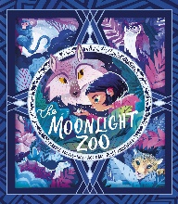 | The Moonlight Zoo  Author – Maudie Powell-Tuck | Eva has looked everywhere for her missing cat, Luna. Then she discovers the Moonlight Zoo – a magical place for all lost animals. Eva the main character wears a hearing aid.
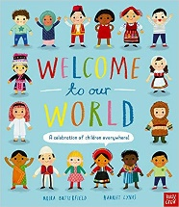 | Welcome to Our World: A Celebration of Children Everywhere  Author – Moira Butterfield | Children all over the world are very different, but they also have much in common. In this beautifully illustrated book, young children can learn all about what people in other countries eat, wear and play, and how they speak and celebrate. One of the characters wears a hearing aid.
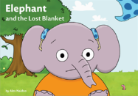 | Elephant and the Lost Blanket  (Available from the NCDS Website)  Author – Alex Naidoo | Elephant and the Lost Blanket stars Elephant, who wears hearing aids, and Tiger, who wears cochlear implants.
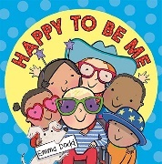 | Happy To Be Me  Author – Emma Dodd | The illustrations include a young boy wearing a bright blue hearing aid in his right ear. There is also another child wearing glasses and a child sitting in a wheelchair.

Stories which include deaf characters (No Equipment)

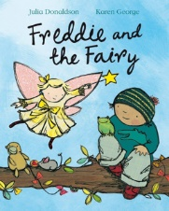 | Freddie and the Fairy  Author – Julia Donaldson | Freddie wants nothing more than a pet, so when the fairy Bessie-Belle offers to grant his wishes, he knows just what to ask for. But Bessie-Belle can’t hear very well and Freddie tends to mumble, which means the wishes aren’t turning out as planned!

