**Finance/buyers/shopping tasks**

**before the end of term**

**Purchasing cards**

If you have a purchasing card or are an approver for a purchasing card make sure all transactions from 1 June to 15 July are reviewed and approved by 5pm on 15 July.

If you use your purchasing card between 16 July and 22 July, remember to review and approve these transactions before the end of term.

If you approve purchasing card spend select specific dates as follows:

1. Log into the approver account, select the ‘Financial’ tab and then ‘Account Summary’.

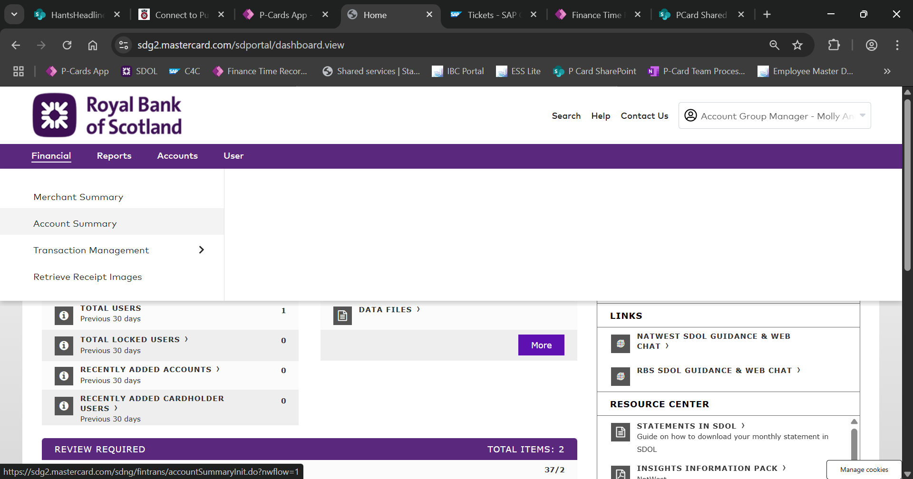

1. Then select the approver name under ‘Quick Link’.

1. Once you have selected the approver name search by ‘Reporting Cycle’ by a date range, as shown below.

This is section is where approvers can search by Reporting Cycle (by clicking on the drop down menu)

This is section is where approvers can search within a specific date range (by clicking on the calendar icon next to the dates)

**Record local banking**

All cash and cheque income must be banked before the end of term.

One the day you bank these items, complete ‘Record Local Banking’ in IBC.

This is an essential fraud control measure and ensure the income is correctly posted to your school’s budget.

**Petty cash (imprest) accounts**

To help keep your account in credit and avoid any issues over the school holidays:

* Review and reconcile your petty cash account at least one week before the end of term.

This allows time for your claim to be approved and the account topped up before the end of term.

Taking these steps helps prevent the account from going overdrawn during the summer break.

* Account signatories – ensure all account signatories are up to date. If there have been any staff changes, request updates to the signatories to remove or add individuals, as needed.

**Substitutions**

Headteachers can set someone as their finance substitute in IBC self-service by using ‘Manage Substitution’. For [help](https://schools.oxfordshire.gov.uk/integrated-business-centre-ibc/help-self-service-ibc) with setting up a substitute check the guidance in IBC, by searching for substitute.