

School Closure request developments

Brief overview
School Closure requests will be submitted through a new online form. This will replace the use of the current submission via the MS From link. The current MS Form will still be live as a precautionary for the changes and then removed when necessary.
We will expect the new form to be used from Monday 4th November 2024.
Expect the link to the School Closure Form to be accessed via the School Intranet platform for easy access.
The fields to be completed should be familiar with the existing format when submitting. We have attempted to improve fields as selections as much as possible to reduce manual typing and time.
We now look to inform interested parties of when the school is expected to re-open instead of daily, single closure requests submitted, resulting in only one submission for the duration of the school closure.
The Oxfordshire County Council public school closure website will be updated with key information for each request about the school, including Status, Reason Date closed from to Date expected re-opening, and details that are provided by the school. E.g. Partial closure for Year 3 classes.

Developments
A new look form will result in improved understanding about the closure with the sense of familiarity when schools complete the fields.
A drop-down selection of your school to click instead of manually typing. This includes your school DfE number beside the school selected.
A drop-down selection for specific reasons to close the school, with other being reported in the detail.
Additional field in the form to inform when your school is expected to reopen; this can also be used to extend the reopening date if required by submitting another form of the same reason to extend the date of reopening. OCC will then administer to make the update.
A code word remains for validation purposes when the closure requests, with OCC validating the request as genuine based on the entered code word. If incorrect, the request will not get processed.
Images of the new look form
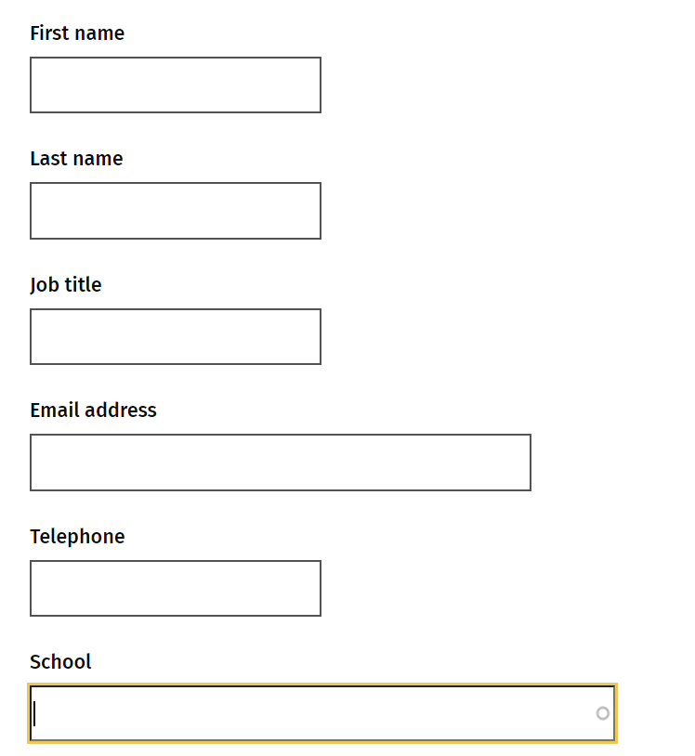
Fields to be entered for school representative for closure request.
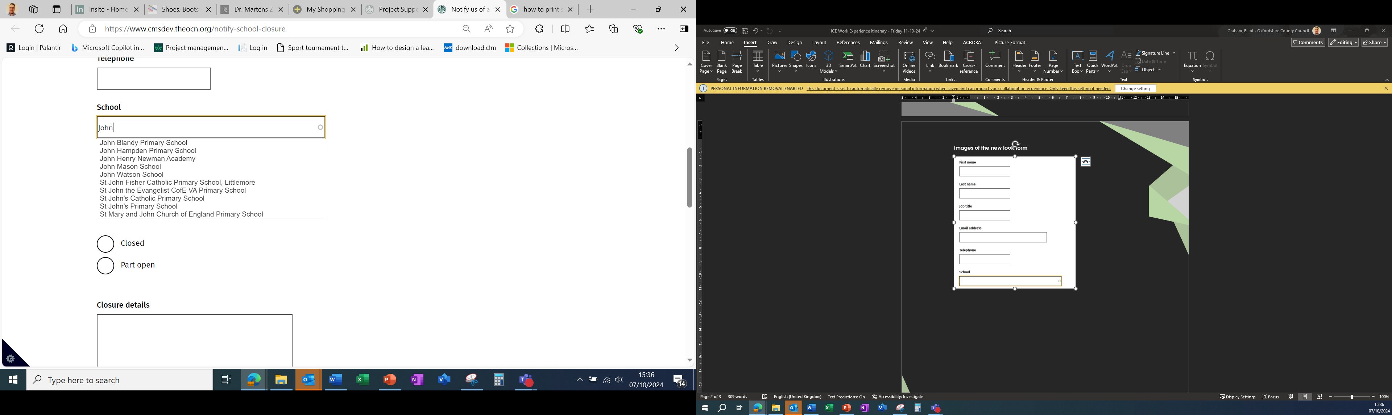
Enter the school name via a directory choice when start typing the name.
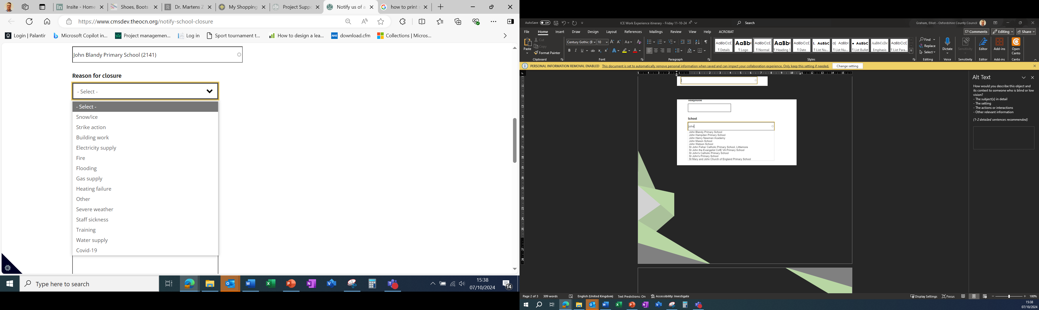
Reasons for the closure is a drop-down choice to select.
The selected school will include the DfE number of the school automatically.

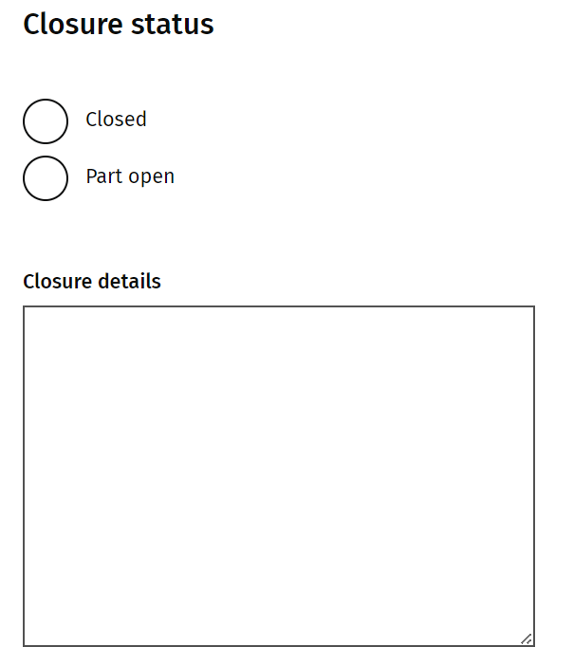
Closure status is for full closure of the school or partial closure with details for both types of closure required.

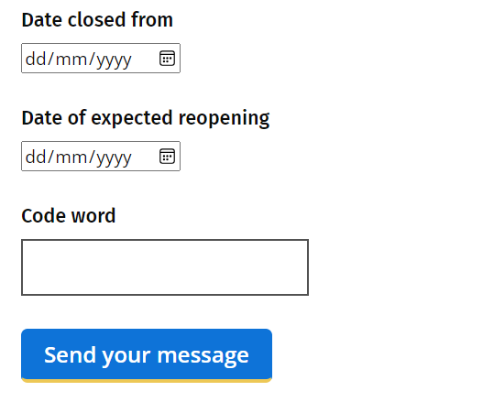
Enter the known code word and submit your request by clicking ‘Send your message’.
Apply the start date of the closure and the expected reopening date (any extension of closure, a new submission is required with the new reopening date, including the same reason.

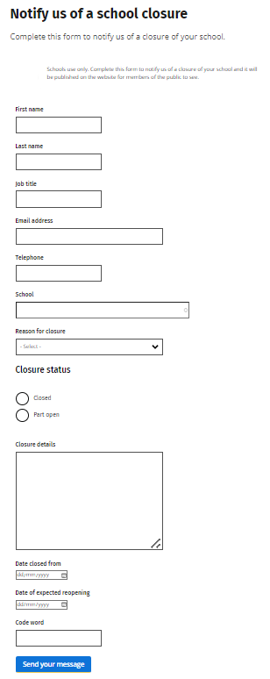
Full Form layout

