Spotlight on success: Opening school facilities funding

The strategic use of opening school facilities funding by Orchard Meadow and Hill View primary schools demonstrates innovative thinking in supporting pupils’ needs beyond the traditional classroom environment. By focusing on physical activities tailored to individual requirements, such as sensory circuits, these schools are fostering an inclusive and supportive educational atmosphere.

This funding has enabled these schools to broaden the opportunities for physical activities outside of school hours whilst connecting them with the local community. It has also added opportunities for pupils with SEND to engage in activities during the school day.

Claire Ferens, Executive Principal, identified the need for supporting specific pupils to enable them to be successful in a classroom setting. A key part of this was providing physical activities that meet their needs. Amongst other things, both schools have used the funding to develop sensory circuits that are used before school and after lunch.

Many children will benefit from engaging in a short Sensory Circuit at the beginning of
Sensory circuits will help anyone that presents with any of these behaviours and difficulties:

• Fidgeting and changing position a lot in class
• Slow to start work and missing verbal cues (needs alerting)
• Difficulty organising themselves
• Lethargic (needs alerting)
• Poor coordination & balance
• Known sensory processing difficulties (requires help with regulating these)
• Rocking
• Poor attention and concentration
• Over-alert and appear hyper (needs calming)

A Sensory Circuit is a short plan of physical activities that enables children to achieve an optimal level of alertness. It lasts 10-15 minutes and consists of 3 sections:

Alerting Activities Organising Activities Calming Activities

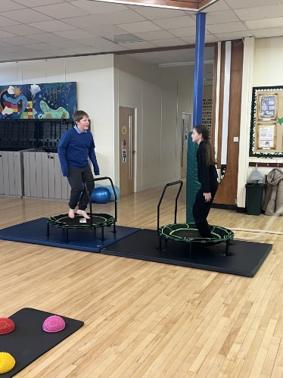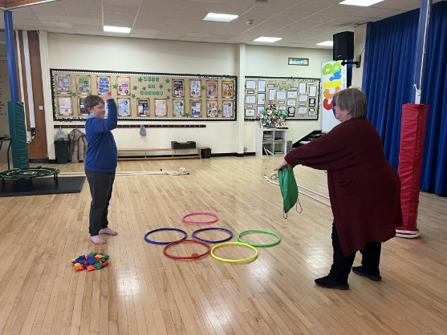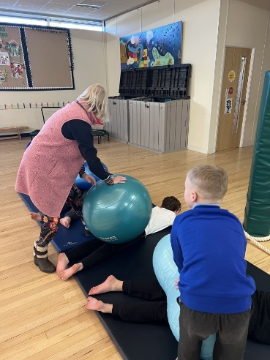

For more information about sensory circuits, please contact CFerens@hillview-school.co.uk.
To discuss the opening school facilities fund, please contact Dean Woodham dw.nossp@bgn.oxon.sch.uk

