Primary PE and Sport Premium

All children should have equal access to high-quality PE provision and opportunities to experience and participate in a wide range of sports and physical activities.

Schools should use the PPSP funding to help achieve these aims. It must not be used for core-type school activities.

They should use it to make additional and sustainable improvements to the PE, sport and physical activity they offer. This means that you should use the premium to:

  - Develop or add to the PESSPA activities that your school already offers
  - Build capacity and capability within the school to ensure improvements made now will benefit pupils joining the school in future years.

Schools should prioritise spending to improve in 1 or more of the following 5 key areas:
    - increasing all staff’s confidence, knowledge and skills in teaching PE and sport;
    - increasing engagement of all pupils in regular physical activity and sport;
    - raising the profile of PE and sport across the school, to support whole school improvement;
    - offer a broader and more equal experience of a range of sports and physical activities to all pupils;
    - increase participation in competitive sport.

Conditions of spend
- Updated guidance was published on DfE website on 19th July 2023: https://www.gov.uk/guidance/pe-and-sport-premium-for-primary-schools?fbclid=IwAR2iUYmecEEoxN4RKanDPQmqTsIJNcwtdlAJuEsAGhbqtvK2UxnT37IM-fc
- The allocation for schools (with more than 16 pupils) remains at £16,000 plus £10 per pupil in Y1 – Y6 (based on Jan 2023 census)
- If you are unsure as to what this amount is, you can check here: https://skillsfunding.service.gov.uk/view-latest-funding/
- Schools will receive 2 separate payments:
  - 7/12 of your funding allocation Oct/Nov (LA/Academy)
  - 5/12 of your funding allocation April/April
- Schools cannot roll over any unused funding into the following academic year. They MUST spend the funding before 31 July 2024.

Funding must not be used for:
- capital expenditure
- employing coaches or specialist teachers to cover PPA -this should be funded from the school’s core staffing budgets;
- teaching the minimum requirements of the national curriculum or, for academies, the existing PE curriculum – apart from top-up swimming lessons. This should be funded through core funding;
- buying services that will be delivered or used in following academic years (this includes paying for invoices/subscriptions in advance);
- goods that exceed the de minimis (lowest) value for purchases set by the school;
- buying staff PE kit.

Examples of what comes under capital expenditure include:
- multi-use games areas and Daily Mile tracks
- Forest School environments and Trim Trails
- buying vehicles
- fixed playground equipment, such as climbing frames
- trophy cabinets or similar

Examples of what schools should pay for from their staffing budget:
- subsidising core staffing, such as PE subject leaders or external coaches who are engaged in repeated annual initiatives;
- funding the cost of a teaching assistant or apprentice to deliver PE lessons instead of primary teaching staff.

Reporting requirements
- The school’s senior leadership team should make sure that the funding is spent for the purpose it has been provided - that is to make additional and sustainable improvements to the PE, sport and physical activity offered.
- All schools must have their reporting template published on their website by 31st July 2024.
- The report MUST contain:
  - the amount of PE and sport premium received;
  - a full breakdown of how it has been spent, including justifying any additional costs incurred and describing;
  - the measurable impact that the school has seen on pupils’ PE attainment, physical activity and sport participation;
  - how the spend will be sustainable in the future;
  - Y6 swimming data.

Reporting template
- https://www.afpe.org.uk/physical-education/evidencing-the-impact-guidance-template/
- Revised into 5 sections:
  - 1) Review/reflection of 2022/23 spend and the evidence of impact
  - 2) Key priorities and planning – linked to key indicators (3 Is)
  - 3) Key achievements 2023/24 – populate throughout the year or at the end of the year, before publishing
  - 4) Swimming and water safety data
  - 5) Sign off – Headteacher, Governor and PE Lead

This should be a working document, don’t leave it all to do in July!

Considerations
Achieving sustainable outcomes is key to any spending of the PE and Sport Premium.

Before making any decisions on what the funding should be used for, schools (in particular, Governors and trustees) should consider how the spending will benefit future pupils and what the lasting legacy of this spending will be.

Schools should focus their efforts on upskilling the whole staff workforce, so that they feel confident and able to lead a PE lesson independently.

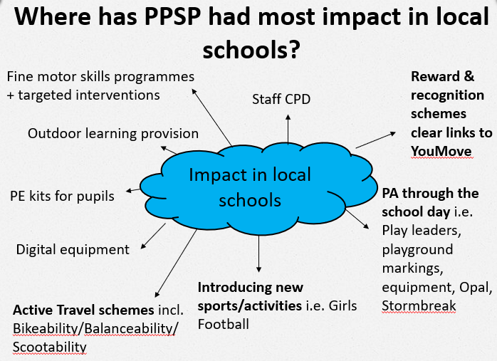

If you require any support with your PE and Sport Premium please contact Natalie.robb@oxfordshire.gov.uk

