Channel: School newsletter
Date: January/February
Header/Subject: New financial wellbeing benefits - Salary Finance

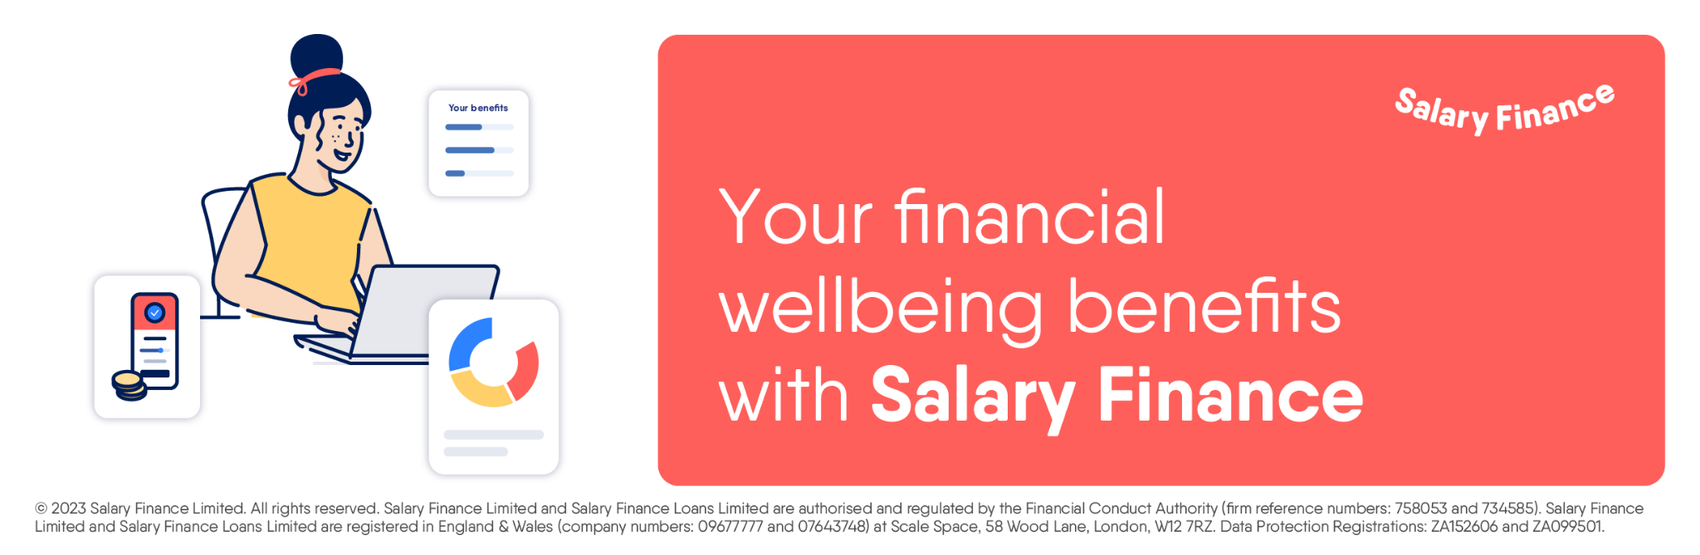

With the continued pressures around the current cost of living squeeze, money is on many people’s minds right now, and having access to benefits and support that could make a real difference has never been more important. To support our colleagues’ financial and mental wellbeing, we have launched a new employee benefit called Salary Finance. Use the QR Code below to find out more:

We’re pleased to announce that starting from January, Salary Finance will also be available to Oxfordshire County Council’s school staff (NB: this benefit is only available to the schools that use IBC for payroll purposes). This includes:

- Affordable loans repaid through salary which could be used to pay off expensive debts and avoid payday loans or credit cards - Representative Rate 9.9% APR (fixed).
- Advance earned pay: the ability to access some of your earned pay ahead of your regular payday. Make payday when you need it and avoid relying on overdrafts and credit cards.
- Simple savings: savings account with contributions transferred directly from your salary, helping you to save without the hassle.
- Help to Save: with this government-backed scheme, anyone receiving Working Tax Credit, Universal Credit or Child Tax Credit could earn bonus payments on their savings. Earn up to 50p for every £1 saved.
- Money insights: a range of tips and videos as well as tools for budgeting and saving to help make money simple.
To find more about the financial support available to you via Salary Finance, visit: occ.salaryfinance.com. To log in, you’ll simply need your name, date of birth and national insurance number.
Important: The “Advance” product is not a regulated lending product. This is an option, not a recommendation. Oxfordshire County Council does not benefit from offering this service and all your communications will be with Salary Finance. Loan applications will be assessed to ensure the loan is appropriate and affordable for you. “Learn” content is for guidance and educational purposes only and is generic in nature. Salary Finance does not offer regulated financial advice. Please seek independent financial advice.

