This document is eight pages long
External learner registration process
Oxfordshire schools
- To access the purchasing card e-learning, which you have to complete before you can apply for a purchasing card, you have to register to use the Learning Zone.

- Contact the Learning Zone administrators via course.booking.enquiries@hants.gov.uk to let them know you need access.

- Once approved, you’ll be provided with a registration code, customer number and organisation ID. Keep this information to hand as you’ll need this to register for an account. (This can take up to five working days to receive).

- Once received, you’ll need to navigate to the external learner page which can be accessed via the following link:
https://hampshirec.plateau.com/learning/user/portal.do?siteID=OCC%5fExternals&landingPage=login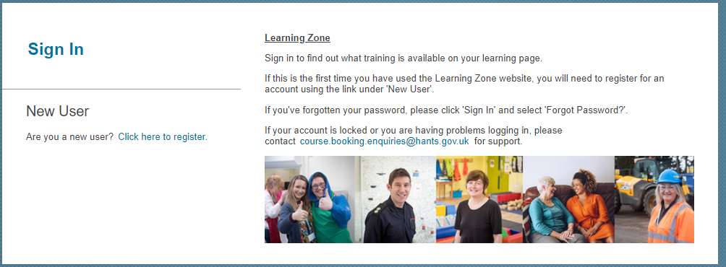
Note: We recommend you bookmark this website for future use.
- Under ‘New User’, select ‘Click here to register’

- Fill in all of the required information and read the Privacy Statement. If you agree with the statement, check the box, and select Submit.
Important: Please note, to register for an account you must use a unique email address. Please refer to the ‘Frequently Asked Questions’ section below for more information.
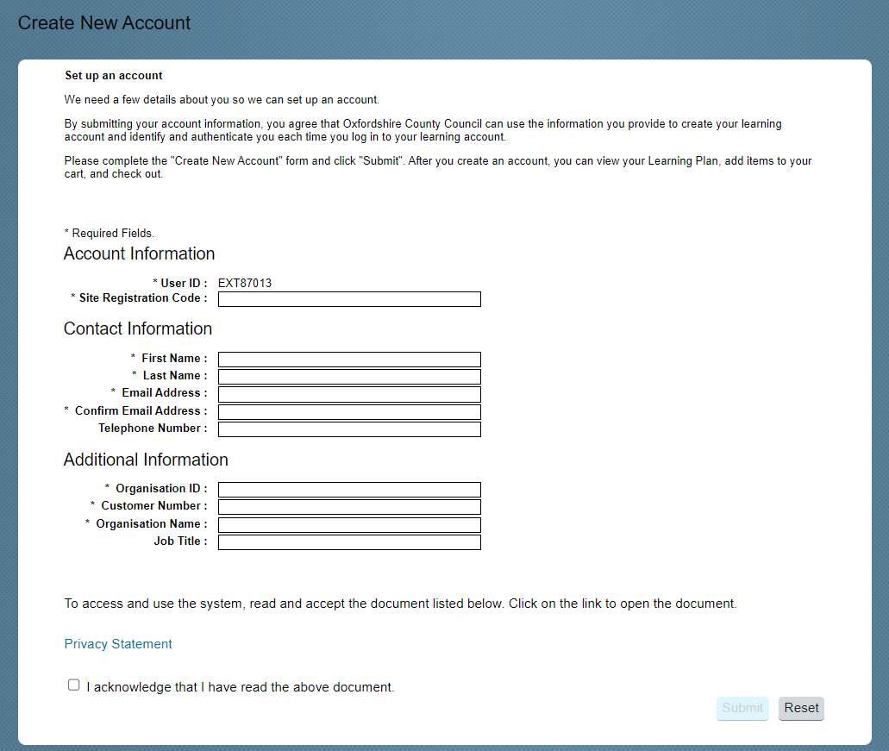
- If you’ve registered successfully, a new page will load thanking you for registering, and informing you that an email will be received within the next hour with a link to activate your new Learning Zone account.
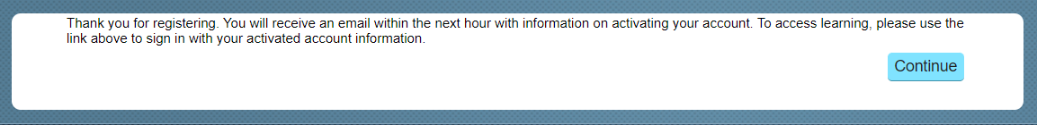
- Once your activation email has been received, select ‘Click here to activate your account’
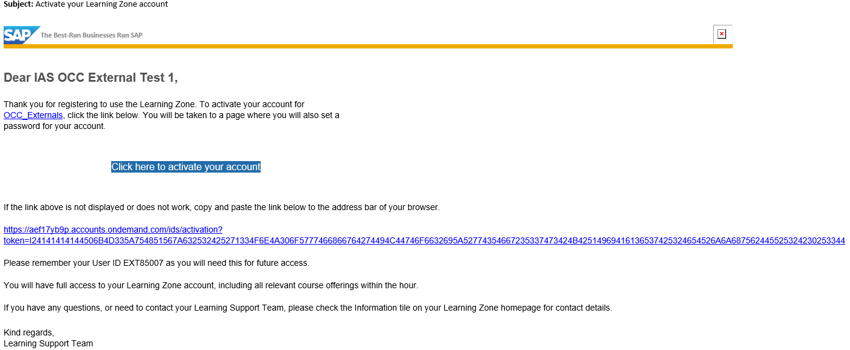
Note: A User ID will be given to you on initial registration and within the activation email received. We recommend you make a note of this for future use.
- You’ll be taken to the activation screen, where you’ll be asked to set a password for your account. Enter a memorable password and select Save.
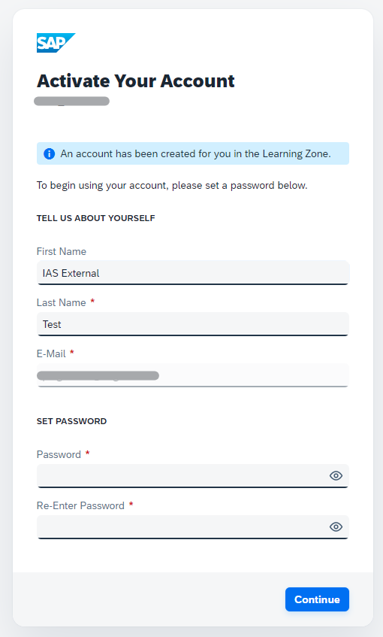

- Once your password has been set, a message will display confirming your account has now been successfully activated. Select Continue.

- You are now logged into the Learning Zone and will be directed to your ‘My Learning Assignments’ page.
Configuration incomplete Fully configured
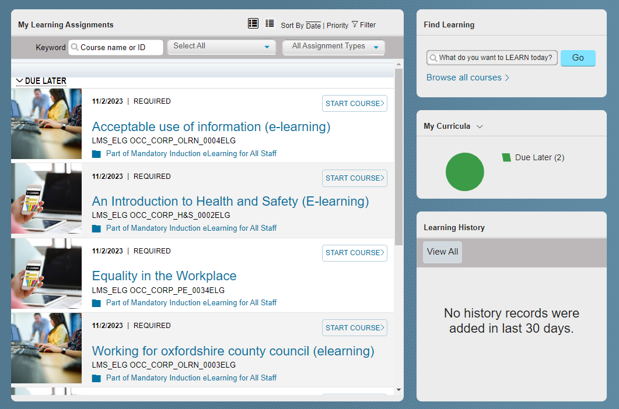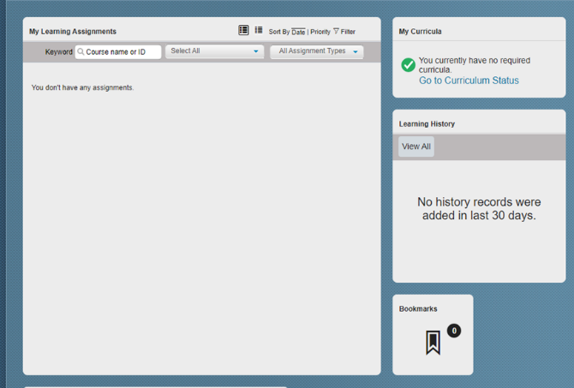
Note: Allow up to an hour for this page to fully configure. Once complete, you’ll be able to search for learning .
Important: On your second login you’ll be asked to set security questions for your account. Once completed, select Continue to access your Learning Assignments.
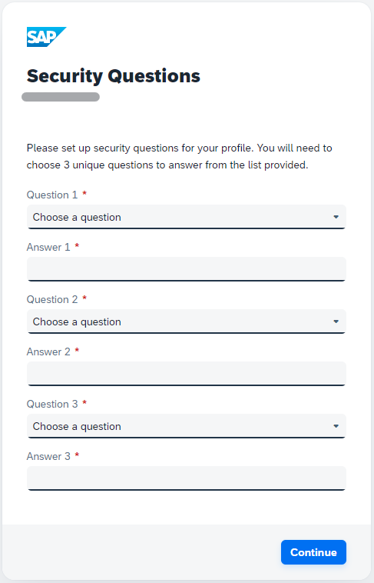

- Search for ‘Purchasing cards’ in the search bar to find the e-learning course

Frequently asked questions
I’ve received an error message saying the email is already in use, how do I proceed with my registration?
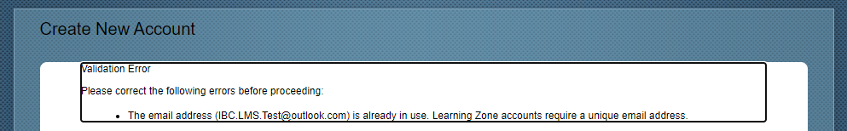
To register for a new external learner account you must use a unique email address.
If you’ve previously had access to the Learning Zone via another account, please use this account to login.
If you’ve forgotten your user ID or password, navigate back to the main external home page and select ‘Sign In’. Here you can select ‘forgot password’ and enter your email address to reset your password for your account. An email will be sent to your email with a link to reset your password.
If you haven’t previously had access to the Learning Zone via another account but are trying to register with a shared email account (e.g. shared work email), you will need to use a unique email to proceed as another user is already using this email.

I’ve received an error message stating my site registration code is invalid, how do I proceed with my registration?

Please contact the administrator course.booking.enquiries@hants.gov.uk, so they can advise.

I haven’t received an activation email, how do I proceed with my registration?
If you haven’t received your activation email after one hour, we recommend that you check your junk mail and check to see if emails are being received to your inbox.

If you’ve still not received an email after 24 hours, please navigate to the main external home page and select ‘Sign In’. Here you can select ‘forgot password’ and enter your email address to reset your password for your account. An email will be sent to your email with a link to reset your password and you’ll be able to activate your account through this feature.
I can’ login to my account. I’ve received an error message stating ‘Invalid E-Mail, User ID or Password. Please try again.’
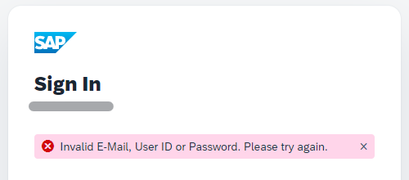
Make sure you’ve entered the correct e-mail, user ID or password. If you’re confident that the details entered are correct, we recommend you attempt to reset your password. To do this, you will need to select ‘Forgot Password’ and enter your email address to reset your password for your account. An email will be sent to your email with a link to reset your password.
If no email is received and you’re still not able to get access , contact: LearningDevelopment@Oxfordshire.gov.uk, so they can investigate the issue.

