Return of EYFSP, Phonics and Key Stage 1 – S2S via DfE Sign-in

Schools should use S2S via DfE Sign-in to return EYFSP, Phonics and Key Stage 1 data to the LA. This should be done by following the guidance below.

Log onto DfE Sign-in (education.gov.uk)

You will now see the DfE Sign-in login page.

Enter the DfE sign-in username and password for your school and click login.
In the “My Services” section select S2S

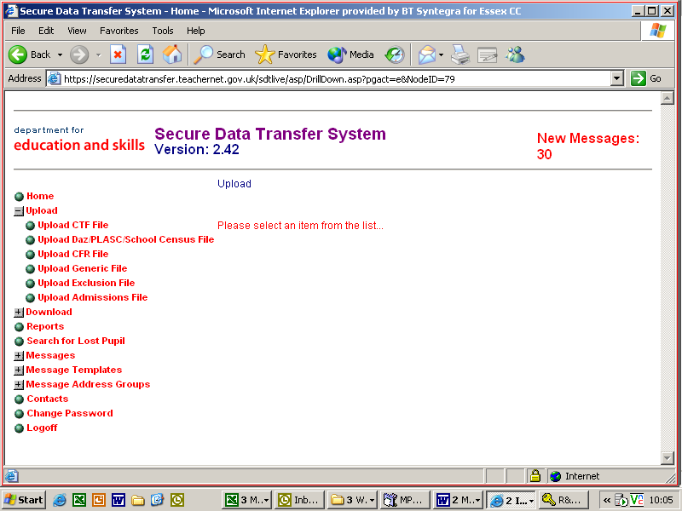
Select ‘Upload’ from the menu on the left hand side of the screen.
From the Upload menu on the left hand side of the screen, select ‘Upload CTF File’.

IMPORTANT
Schools must click on the ‘choose file’ function to find the file. If the file path is typed in this results in an empty file being returned.

- Use the choose file function to find the EYFSP, Phonics or KS1 file stored on your directory. The file name should be in the following format 931SSSS_CTF_931LLLL_NUM.XML

  - SSSS is your school DfE number.
  - CTF should be changed to FSP, PHO or KS1 to identify which return the file is for
  - NUM is a file name e.g. 001, 002, or 100, 101, which increases each time a file is created. (To check you have located the most recent version, hover over the file name with your cursor to see ‘date modified’.)
  - LLLL signifies the file is being sent to the LA.

This file name must not be changed.

- Once the file has been located, click on the file name and click ‘Open’ and the box ‘Select Folder & File Name’ will be populated with the file.

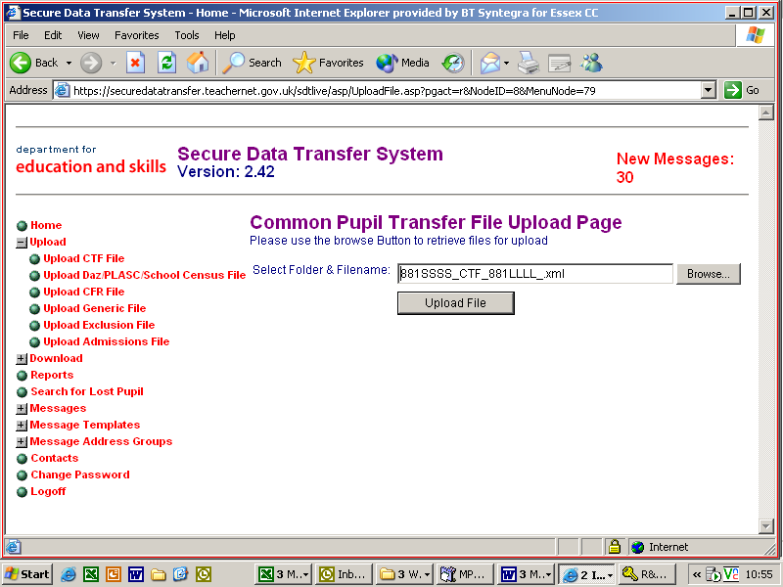
Click ‘Upload file’.
A warning box will appear to say this could take up to five minutes to upload

- Click ‘Upload file’.

- A warning box will appear to say it could take up to five minutes to upload. Click ‘OK’.

- Once the upload is complete a message will appear to say the file has been transferred to the web site. It is important that you wait for this message because if you exit the screen before it may cause the data transfer to fail.

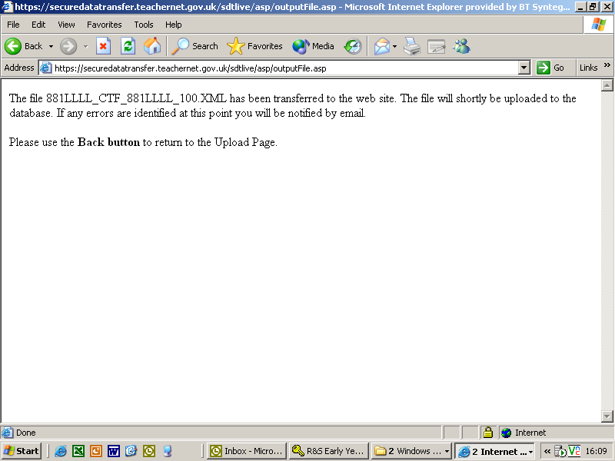

- When the file has been successfully transferred to the website, use the Back button on your toolbar to return to the previous page and choose ‘Logoff’ from the menu on the left.

