OCC Model Anti-Bullying Policy

Introduction and Aims

At *********************** School/ Trust, we are committed to working with children, staff, governors and parents/carers to create a school environment where similarities are identified and celebrated, difference is valued and nurtured, and bullying, harassment and violence are never tolerated. This policy aims to help both prevent and tackle bullying in equal measure.

[Refer to your school’s ethos and values in the next paragraph. For example:

*********************** School/ Trust is a caring, safe place where everyone is equal. Inspired by the Holy Spirit and guided by the teachings of Christ, we know, love and respect each other. In our school, we help each other to be the best that we can be. Everyone at *********************** School/ Trust should be treated with respect and kindness.]

Bullying of any kind is unacceptable and will never be tolerated at our school.

At *********************** School/ Trust, we expect our children to be:

- [List your values]

We actively encourage every child to embrace and live by the above values, thereby developing knowledge, skills and attitudes which enable them to develop as reflective learners and grow to be stable, educated, respected and respectful adults in modern Britain. It is our duty to prepare every child for what will be expected of them by society, their secondary school, workplace or further study setting.

The purpose of this policy is to ensure a consistency of approach to hurtful behaviour and bullying within our school community. While we must understand that we are all individuals, everybody has the right to feel safe, all of the time.

While bullying and making mistakes is a fact of life, bullying will not be tolerated in or outside of our school.

This policy should be read in conjunction with the following school policies:
- Behaviour Policy
- E-Safety / Cyberbullying Policy
- Equalities Policy
- Exclusions Policy
- Relationship and Sex Education Policy
- Safeguarding Policy
- SEND Policy

What is bullying?

“Bullying is the repetitive, intentional hurting of one person or group by another person or group, where the relationship involves an imbalance of power. It can happen face-to-face and online.”

- Anti-Bullying Alliance
Table 1: Source - Psychology Today  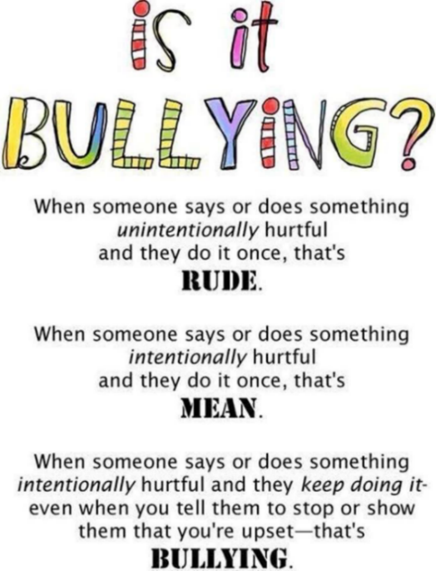 | Whether intended or not, hurtful behaviour must be challenged.  Everybody has the right to feel safe.  No form of bullying will be tolerated in our school and all incidents will be taken seriously.

Below are some factors that can make people vulnerable to bullying:

When dealing with bullying-related incidents, schools must refer to the Equality Act 2010 and the 9 protected characteristics within it.

Children and young people who are at most increased risk of being the victims or perpetrators of bullying can be those who:
- are in foster care or residential homes (Children We Care For)
- are understood to be at risk from a range of safeguarding or Child Protection issues – e.g. organised crime groups
- have specific special educational needs – e.g. Autism
- have a disability or impairment
- are from minority ethnic backgrounds
- are refugees or asylum seekers
- start school or an activity group mid term
- are, or are perceived to be, gay, lesbian, bisexual, transgender or questioning of their sexuality or gender
- speak a first language other than English
- are young carers
- have suffered bereavement
- have suffered domestic violence
- have experienced physical or emotional trauma
- have a parent that was a victim of bullying
- experienced poverty or deprivation
- are perceived as different in some way

Types of bullying:

Bullying behaviours can include:

The repeated negative use of bodily contact to intentionally hurt others.
- Physical harm – e.g. hitting, kicking, tripping up, spitting, taking or damaging property, use of threat or force in any way, intimidation or demands for money or goods.

The repeated negative use of speech, sign language, or verbal gestures to intentionally hurt others.
- Verbal harm – e.g. name calling, insulting, teasing, ‘jokes’/banter (click here to view the Anti-Bullying Alliance’s ‘Banter or Bullying?’ webpage), mocking, taunting, gossiping, secrets, threats. Reference to upsetting events - e.g. bereavement, divorce, being in care.

The repeated negative use of actions, which are neither physical nor verbal, to intentionally hurt others.
- Non-verbal harm – e.g. staring, body language, gestures.
- Indirect harm – e.g. excluding, ostracising, rumours and stories, emails, chat rooms, messaging phones, notes, inappropriate gestures.

The repeated negative use of technology as a medium to intentionally hurt others.
- Cyber harm – e.g. text messaging, instant messaging, internet chat rooms, the misuse of social media applications, the misuse of camera or video facilities (including the self-generated inappropriate images), offensive questions and nasty inbox messages.

The repeated negative treatment of another incited by a parent/carer.

We acknowledge that some acts of bullying will constitute a criminal offence (Bullying and the law – Anti-Bullying Alliance). In these cases, we would seek advice from local services. For example, our Police Liaison Officer, the Local Authority’s Anti-Bullying Officer and the Locality and Community Support Services (LCSS).

Bullying outside of school

Bullying is unacceptable and will not be tolerated, whether it takes place inside or outside of school.

‘Where bullying outside school is reported to school staff, it should be investigated and acted on.’
(DfE Preventing and Tackling Bullying, p.6)

For more information, refer to the below Department for Education (DfE) publications:
- Bullying outside school
- Preventing and Tackling Bullying (advice for schools, including advice on cyberbullying)
- Education and Inspections Act (2006)

Bullying can take place on the way to and from school, before or after school hours, at the weekends, during the holidays and in the wider community. The nature of cyberbullying means that it can impact on pupils’ well-being beyond the school day. Staff, parents/carers and pupils must be vigilant to bullying outside of school and report it in the same way that they would if they witnessed bullying in school.

We will follow the same procedures (see ‘Dealing with an Incident’) when it becomes apparent that bullying outside of school is affecting members of our school community. However, if the individual or group causing harm to a member of our community does not attend *********************** School/ Trust, we will seek advice and guidance from local services (e.g. Schools, Police, Children’s Social Care) to ensure action is initiated to address the bullying behaviour.

Possible indicators of bullying

We recognise that the following behaviours may suggest that someone is being bullied:
  - disturbed sleep
  - bed-wetting
  - head and stomach aches
  - problems with concentration
  - changes in behaviour and attitude
  - school refusal
  - bullying other children
  - damaged or missing clothes / money / property
  - asking for more money than usual or stealing money
  - withdrawn or changes in their usual behaviour patterns or attitude
  - distressed or emotional and finds it hard to articulate their feelings
  - changes in their eating patterns
  - changes in their online activity
  - shows evidence of self-harming or even for extreme cases potential suicide
  - is unusually tired without a reasonable explanation
  - has unexplained bruises or marks on their body - some may refuse to change for PE
  - repeatedly comes to school without dinner money or a packed lunch
  - seems afraid to be alone and requires more adult interaction
  - This list is not exhaustive. In addition, these behaviours could also indicate other issues for which schools may refer to their Behaviour and Child Protection and Safeguarding Policies for guidance

School initiatives to prevent and tackle bullying

We use a range of measures to prevent and tackle bullying including:

- A Child-Friendly Anti-Bullying Policy ensures all pupils are aware of the Anti-Bullying Policy and our expectations. This is displayed in every classroom.
- Trained Anti-Bullying Ambassadors represent every class across the school. They meet regularly and work in partnership with staff and other children to consider ways we can continue to effectively prevent and tackle bullying at *********************** School/ Trust.
- Staff are trained in Restorative Practice. Restorative approaches provide support to those who may have been affected by conflict or bullying behaviours. For more information on Restorative Practice, visit Oxfordshire County Council’s Anti-Bullying webpage.
- All staff are trained in Generalist Safeguarding; effectively preventing and tackling all forms of bullying; reporting concerns; and where to go for help and support.
- At *********************** School/ Trust, we have high expectations of behaviour which we promote through our [Your School Behaviour Pledge/Motto] which is displayed in every classroom and around the school (see below).

[IMAGE/EXTRACT SHOWING YOUR SCHOOL PLEDGE/MOTTO]

- RE lessons include opportunities for pupils to understand about how we are all unique and made in the image and likeness of God.
- The RSHE programme of study includes opportunities for pupils to learn:
  - about different types of bullying (including cyberbullying), the impact of bullying, responsibilities of bystanders (primarily reporting bullying to an adult) and how to get help.
  - the importance of respecting others, even when they are very different from them (for example, physically, in character, personality or backgrounds), or make different choices or have different preferences or beliefs.
  - that in school and in wider society they can expect to be treated with respect by others, and that in turn they should show due respect to others, including those in positions of authority.
  - that people sometimes behave differently online, including by pretending to be someone they are not.
  - that the same principles apply to online relationships as to face-to-face relationships, including the importance of respect for others online including when we are anonymous.
- Regular school assemblies, in addition to Anti-Bullying Week in November, help raise pupils’ awareness of bullying and derogatory language.
- Difference and diversity are celebrated across the school through diverse displays, books and images.
- The school values of equality and respect are embedded across the curriculum – we strive to be inclusive in everything that we do.
- Pupils are continually involved in developing school-wide Anti-Bullying initiatives through consultation with the Pupil Parliament, the Anti-Bullying Ambassadors and any child who has been affected by conflict or bullying. As a restorative school, we aim to work ‘with’ children and their families in order to effectively prevent and tackle all forms of bullying.

Reporting – Roles and Responsibilities

Governors

The Governing Board have a duty to ensure the school has policies in place to effectively prevent and tackle all forms of bullying and for reviewing the effectiveness of such policies.

Headteacher

It is the responsibility of the headteacher, with the support of senior leaders, to implement the school’s Anti Bullying Policy consistently throughout the school and to report to governors, when requested, on the effectiveness of the policy. It is also the responsibility of the headteacher to ensure the health, safety and welfare of all children in the school, with the support of the Designated Safeguarding Lead.

The headteacher must ensure that the Anti-Bullying Policy is consistently implemented by all staff by setting the standards of behaviour expected and by supporting staff, through appropriate training, in the implementation of the policy.

The Headteacher, supported by class teachers, is also responsible for ensuring expectations of behaviours are clear to all children and that children know what to do if they or somebody else is being mistreated or bullied.

Where appropriate, the headteacher should seek advice in order to address complex cases of bullying; it is not always possible to effectively resolve every case by following the steps outlined in ‘Dealing with an Incident’ section. Indeed, every case will be unique.

Anti-Bullying Lead

The Anti-Bullying Lead, with the support of the headteacher and Anti-Bullying Ambassadors, is responsible for ensuring measures are in place to effectively prevent and tackle all forms of bullying.

In addition, the Anti-Bullying Lead is responsible for ensuring every member of the school community is clear on the approach to preventing and tackling bullying at *********************** School/ Trust.

Our Anti-Bullying Lead is: [Name of Anti-Bullying Lead]

Staff (Teaching and Non-Teaching)/ Adult visitors

Staff

All adults encountered by the children at school have a responsibility to model and promote respectful relationships, both in their dealings with the children and with each other, as their example has a huge influence on the children. All adults have a duty to encourage positive behaviours and challenge any negative behaviours. At *********************** School/ Trust, we believe that the behaviour we walk past is the behaviour we accept.

All adults at *********************** School/ Trust should aim to:
- create a positive environment with high expectations;
- emphasise the importance of being valued as an individual within the group;
- promote, through example, honesty and courtesy;
- provide a caring and effective learning environment;
- encourage relationships based on kindness, respect and understanding of the needs of others;
- ensure fair treatment for all regardless of age, gender, race, ability and disability;
- show appreciation of the efforts and contributions of all.

Staff, governors and regular volunteers are trained to be vigilant to the signs of bullying and to play an active role in the school’s measures to prevent bullying. If adults become aware of bullying, they should reassure the children involved that they will act, follow the steps outlined in ‘Dealing with an Incident’ and inform their class teacher without delay.

Pupils

All children have a duty to report bullying. If children become aware of hurtful behaviour, they should reassure the children involved that they will act and inform an adult without delay.

Refer to Child-Friendly Anti-Bullying Policy.

Role of Parents / Carers

At *********************** School/ Trust, we aim to work closely with parents/carers so that our children receive consistent messages about appropriate ways to behave in and out of school. Behaviour expectations are clearly communicated via parent newsletters, our website and the Parent/Carer Agreement which is reviewed annually and signed by the headteacher, parents/carers and children.

We expect all parents/carers to support their child’s learning and to co-operate with the school. We work hard to build positive relationships with parents/carers and will always inform parents/carers if we have concerns about their child’s welfare or behaviour.

If the school uses reasonable sanctions to manage a child’s behaviour, it is essential that parents/carers support the actions of the school. If parents/carers have concerns about the way that their child has been treated, they should initially contact the class teacher. If concerns remain, parents/carers should speak with a member of the Senior Leadership Team. If after this, concerns remain, parents/carers should speak to the headteacher.

For more information, go to Oxfordshire County Council’s ‘Help if your child is being bullied’ webpage.

Dealing with an Incident

When bullying has been reported, the following actions will be taken:

Stage 1

- As it can be difficult to identify the bully and bullied in situations of conflict, and once children are calm enough to engage in conversation, staff will work through the 5 restorative steps (which are available on their lanyard) with any child involved in conflict/bullying.

What are the ‘5 Steps of Restorative Practice’?

Step 1: Tell the story - What has happened? Start from the beginning… What happened just before that?
Step 2: Thoughts and Feelings - What were/are you thinking? What were/are you feeling? How do you think they are feeling?
Step 3: Ripples of harm – Who has been harmed and how have they been harmed? What has been the most difficult thing for you?
Step 4: Needs – What do you need in order to find closure? What do you need to move forward?
Step 5: What next? What do you think will make things better? What needs to happen?

Children may initially do this on a reflection form, if emotions are running high, and then talk to staff. Appropriate next steps will be agreed (e.g. restorative meeting, letter of apology, etc.) and the class teacher and parents, of all children involved, will be notified.

- The incident will be recorded on CPOMS/MyConcern without delay (see Appendix).

Stage 2

For serious behaviour incidents, skip to Stage 3.

Should children continue to behave in a way that is hurtful to others, Stage 1 will be repeated and the child causing harm will be treated in-line with the school’s Behaviour Policy to safeguard any children who have been harmed by their behaviour. This may, for example, be a period of internal exclusion (1 or 2 days off the playground) and will be decided by the headteacher.

Staff will offer support to any children who have been harmed and take necessary action to make sure they feel safe and reassured – with the children’s consent, this may involve a restorative meeting that produces a written agreement between all children involved.

Stage 3

Should negative behaviours persist following Stage 2 intervention(s) or a serious behaviour incident, the child/children causing harm will be placed on an Inclusion Support Plan (ISP). An ISP (see Appendix) requires positive and negative behaviours to be identified by a relevant member of staff using a QCA Behaviour Assessment (see Appendix). The children who have been harmed should be safeguarded from the harmer until the point a meeting can be arranged with the parents/carers of the harmer. In a meeting involving school, parents/carers and the child, the behaviours causing concern must be acknowledged, possible triggers identified, and a SMART action plan put in place. The ISP should be reviewed weekly with key adults in school.

For any children who have suffered harm, we will assess their needs and, where possible, provide in-school welfare support. For significant cases and cases that constitute a criminal offence, children can be referred to SAFE! Support for Young People Affected by Crime, with the consent of their parent/carer.

Stage 4

Should negative behaviours persist following the implementation of an Inclusion Support Plan (ISP), the headteacher should seek advice* to further consider how to reduce the risk of recurrence as part of a risk assessment/safety plan and implement appropriate safeguards and support for the child.

If a child reaches Stage 4, the school should also work with the parents/carers to initiate an Early Help Assessment (EHA) and Team Around the Family (TAF) – multi-agency meeting - to consider what action is necessary, and in the child’s best interests. Should the family refuse to engage with school in this process, the school will seek support from the Locality and Community Support Service (LCSS) to engage the family. TAF meetings should take place every 6 weeks. Progress against PSP goals should be reviewed as part of the TAF.

* At Stage 4, the headteacher should also refer to the Learner Engagement Team’s Guide for school leaders and agencies supporting school-age children / young people at risk of exclusion from school.

In all of these cases, a multi-agency meeting should be arranged to reduce the risk of exclusion:
- If a child has an Education Health and Care Plan you must contact your SEN Officer to discuss the risk of exclusion
- If the child is a Looked After you must contact the Virtual School for Looked After Children
- If the child is open to social care (Child in Need or Child Protection) you must contact the social worker

Safeguarding

When there is ‘reasonable cause to suspect that a child is suffering, or is likely to suffer, significant harm’ a bullying incident should be addressed as a child protection concern under the Children Act 1989. Where this is the case, school staff should discuss with the school’s designated safeguarding lead and report their concerns to their local authority children’s social care and work with them to take appropriate action.

Special Educational Needs and Disabilities (SEND)

The headteacher should take account of any contributing factors when dealing with incidents of bullying. Early intervention to address underlying causes of bullying behaviour should include an assessment of whether appropriate provision is in place to support any SEN or disability that a pupil may have. Under the Equality Act 2010, schools must not discriminate. For disabled children, this includes a duty to make reasonable adjustments to policies and practices.

Should the behaviour of a child with any SEN or disability be causing significant harm to others and there is an Education and Health Care Plan (EHCP) in place, the school must request an emergency annual review.

Recording and Reporting

*********************** School/ Trust records incidents of bullying on CPOMs/MyConcern (see Appendix) and analyses patterns of behaviours as part of weekly Senior Leadership meetings. Reflection sheets, completed by children as part of our restorative approach, are filed in a folder which is stored in the main office. Termly feedback is made available for governors via the headteacher’s report.

Pupil Voice

Pupil voice is central to the culture and ethos of our school. We use pupil voice to evaluate how relevant this policy is to children’s lives and ensuring the feel safe and able to learn.

Monitoring and Evaluation

The headteacher is responsible for reporting to the Governing Board (and the Local Authority/Multi-Academy Trust where applicable) on how this policy is being enforced and upheld. The governors are in turn responsible for monitoring the effectiveness of this policy via the termly headteacher’s report, school monitoring visits and focus groups with pupils. Should a parent/carer wish to pursue a complaint regarding bullying, they should refer to the school’s Complaints Policy before making direct contact with the Governing Board.

This policy is reviewed every 12 months.

Date of last review: DD/DD/YYYY

The policy should be read in conjunction with:

- Keeping Children Safe in Education (statutory guidance)
- Respectful School Communities: Self Review and Signposting Tool (a tool to support a whole school approach that promotes respect and discipline)
- Behaviour and Discipline in Schools (advice for schools, including advice for appropriate behaviour between pupils)
- Equality Act 2010 and schools
- SEND code of practice: 0 to 25 years (statutory guidance)
- Mental Health and Behaviour in Schools (advice for schools)
- Preventing and Tackling Bullying (advice for schools, including advice on cyberbullying)
- Sexual violence and sexual harassment between children in schools (advice for schools)
- Promoting Fundamental British Values as part of SMSC in schools (guidance for maintained schools on promoting basic important British values as part of pupils’ spiritual, moral, social and cultural (SMSC)

Appendix

[Edit this so that it reflects the documents that your school use to record and manage bullying incidents]

CPOMS/MYConcern

[SCREENSHOT OF CPOMS/MY CONCERN OR EQUIVALENT INCIDENT FORM HERE]

Child Reflection Sheet

Key Stage 1

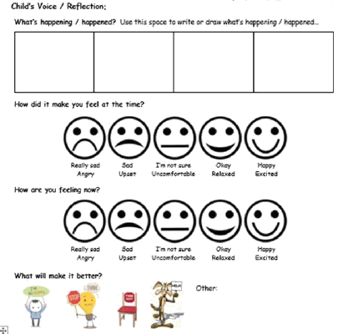

Key Stage 2

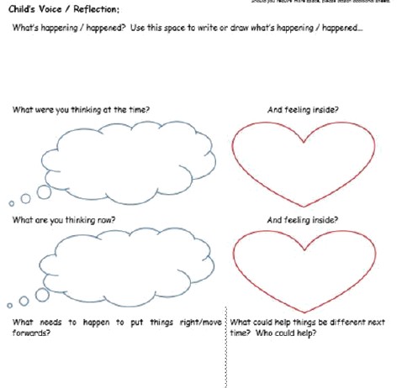

QCA Behaviour Assessment
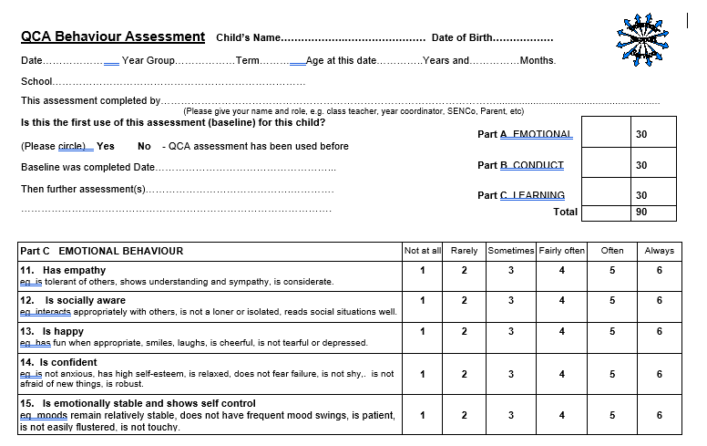
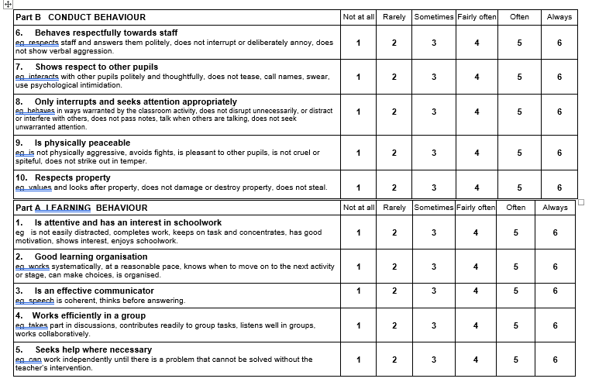

Inclusion Support Plan (ISP)

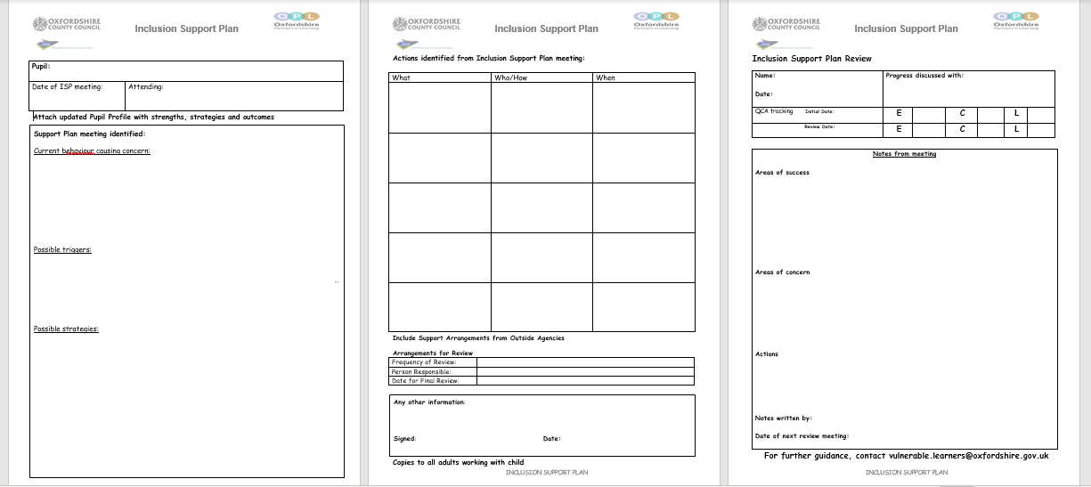

Pastoral Support Plan (PSP)

