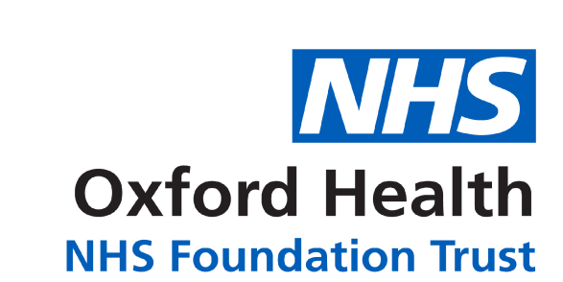

Medical Questionnaire

The professional completing this request for an EHC assessment must talk with parents and young people to gather information about the child or young person’s health needs. Please use the script so that they understand the purpose of the questionnaire:

As part of the Education, Health and Care need assessment process, the Local Authority is required to obtain information from health professionals so they can find out whether any medical condition affects your child’s learning. This information is referred to as ‘medical advice.’ Completing this section helps to make sure the request for medical advice goes to the right person in health to avoid delays in deciding if your child needs an assessment appointment.

Child’s NHS Number (if known)
Name of General Practitioner
Address of medical practice

If your young person is aged 14 and over, does he/ she access the annual health check by their GP? YES/NO

If so, what was the date of the last appointment: ___________________

Does your child or young person miss school because of their health needs? YES/NO

If yes, please give more details.

Medical History:

Does your child/ young person have a diagnosis or any medical conditions e.g. Asthma/Epilepsy/Hearing or Visual problems?
If so, how does this impact on his/her learning or day to day living?

Is he/she under the care of any hospital consultants? If so, please give the consultant’s name and the name of the hospital/clinic and the date of the last appointment.
(Please delete as appropriate)
Community Paediatrician Yes/No
Child and Adolescent Mental Health Service (CAMHS) Yes/No
Adult Mental Health Service Yes/No

Is he/she known to any other Health care professionals? If so, please include the name(s) of the people your child/ young person sees and where they are based.
Is your child/young person waiting for an assessment or have an appointment with any health services? If so please give the reason for assessment, name and contact details of the service.

Information sharing

Signing the Medical Questionnaire enables the Local Authority and NHS to share information about your child so that we can complete a full and accurate assessment of all their needs.

I/ We consent to the Designated Clinical Officer and/or administrator accessing my child’s NHS health records to contribute to the request for health advice for the purposes of the Education, Health and Care needs assessment. I agree that the information can be shared with relevant health professionals to ensure that accurate health advice is returned to the Local authority within six weeks.

Name(s) of legal guardian(s) of the child/ young person
Relationship to the child/young person
Signature(s)

Date

I am 16 and able to give consent
Name of young person
Signature
Date

